Phlebotomy Check In from the Schedule

This tip sheet is for Phlebotomists to Check-In patients from the DAR for routine labs and specimen drop offs.

# Checking In a Lab Patient using the Schedule

## Checking in from the Schedule as a Phlebotomist

1. Select the calendar icon  in the upper left-hand corner of Epic menu to access the **Schedule**.
2. Select the patient’s ***scheduled appointment*** on the schedule.
3. Click **Check In** in the upper right-hand corner of the schudule activity toolbar.

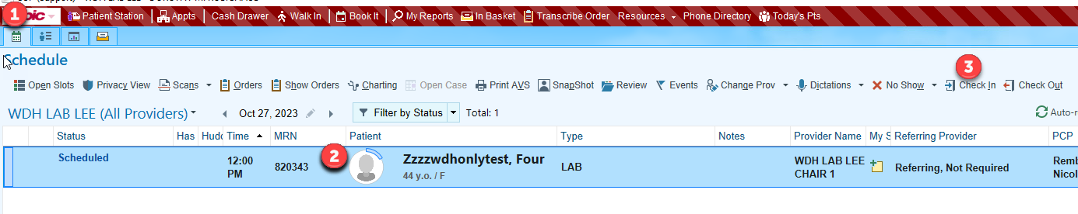

1. 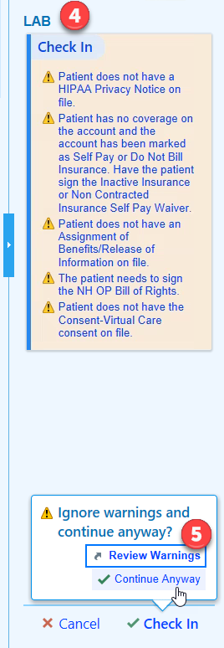Review the Warnings on the checklist and make updates as necessary before proceeding past the confirmation warnings.
2. Click **Continue Anyway** to complete Check-In bypassing any Confirmation Warning that are unable to be satisfied.

## Adding the Open Orders Tab in Chart Review

1. When in **Chart Review** for the first time, click the down facing arrow in the upper right for the *More Menu*. Favorite the **Open Orders** activity by clicking the star next to the right of the name. Once it is added as a new tab, right click on the new tab and select **Mark as Important** to make the tab stand out. You may also right click on other tabs and select **Move to More Menu** to declutter the tab section and limit the available selections.

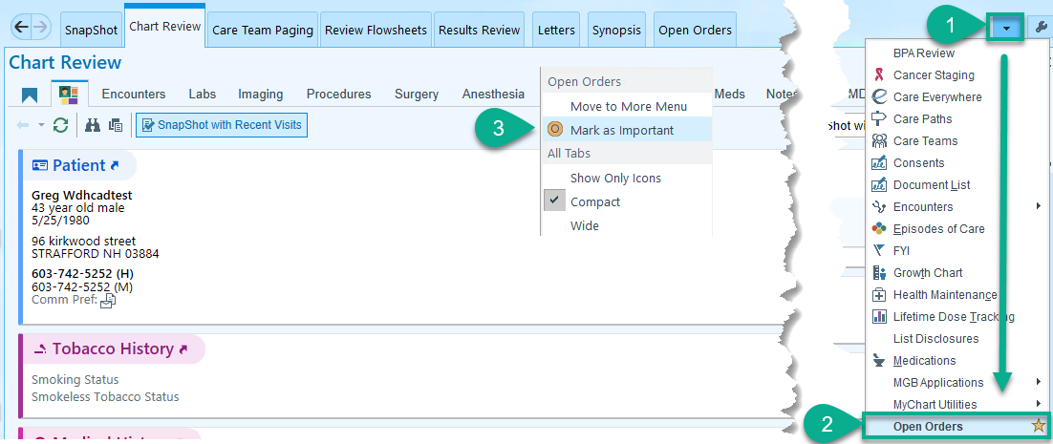

## Releasing the Order from Chart Review, Phlebotomist

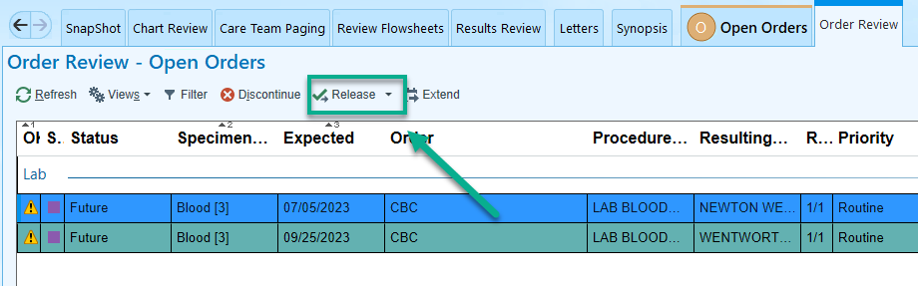

Select the order(s) from the Open Orders table and click **Release**.

## Checking out from the Schedule, Phlebotomist

1. Right click on the patient’s Arrived appointment from the Schedule and select **Check Out** in the upper right-hand corner of the Schedule activity toolbar.

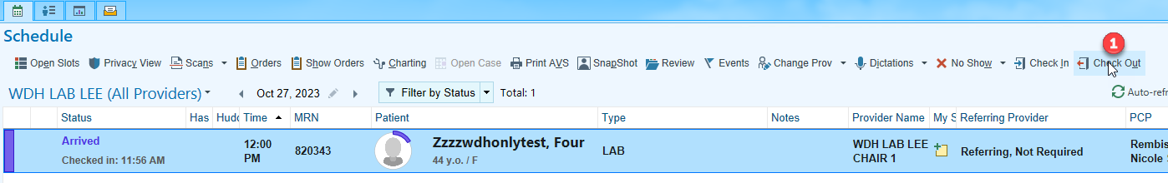

1. Click **Continue Without Scheduling** to continue to Check Out.

### 

1. Review and resolve any remaining applicable confirmation warnings for Lab and click **Check Out** in the lower right-hand corner of the Checklist.

