  Wentworth-Douglass Hospital  Department of Pathology and Laboratory Medicine  Laboratory Section: Phlebotomy  Revision Date: | POLICY / PROCEDURE TITLE:  COMPUTER DOWNTIME PROCEDURE | Approvals:  Medical Director: ____________________________  Prepared By: _Darlene Bickford_________________  Edited by:  Effective Date:  Retired Date: _____________
IF EPIC IS DOWN BUT SUNQUEST IS OPERATIONAL:

- Call the IS help desk at X2420 to make sure IS has been informed that Epic is down.
- Call all nursing units to ask them to fax (or send by transport) Lab requisitions to the lab while Epic is down.
- Call the Emergency Department and ask them to send the order sheet through the tube system with the specimens to the Lab. Additional order sheets may be received from the ED for add-on testing either by fax or through the tube system.
Inpatients and ED patients with a current encounter number:
- When Epic is down Collect will not receive any new information regarding Lab Collect specimens for Inpatients and the ED will not be able to generate labels for the lab draws.
- For inpatient draws a lab requisition must be sent to the lab and the lab will enter the orders into Sunquest using the current encounter number. The orders will transmit to Collect.
- For ED draws, a requisition must be sent to the lab for any lab collect draws or sent with the specimens for Nurse draws. The lab will enter any lab collect requests into Sunquest and pre-print labels prior to presenting to the ED for the collection.
- The technical staff will fax results to nursing units/ED upon completion.
- Once Epic is operational, activate the lab downtime recovery procedure and resume normal operations.

ED and Inpatient Nurse collect specimens: The lab is no longer able to see pending orders for any Nurse/Unit Collect specimens.
- The ED and or Nursing staff will need to manage these draws and send a lab requisition with any specimens obtained or collected during the downtime.
- Each specimen must be labeled with either an ADT label if available or handwritten information to include patient’s full name, date of birth, date and time of collection and the collector’s initials.

Patients without an Encounter number: Patients arriving during the downtime will not be issued a CID in Epic and the lab will not be able to order tests directly into Sunquest.
The use of the Manual Sunquest CID labels will be required. All orders will need to be sent to the lab on a paper requisition and the lab will use the manual Sunquest CID labels to complete the request(s).

Manual Sunquest CID Labeling instructions: Each specimen will have its own CID #. There are 4 CID labels per number.
CID LABEL INSTRUCTIONS:
- Label 1 (Specimen label): Affix to the specimen or the outer most specimen container.
The following information must be written on the specimen label:
      - Test(s) to be performed
      - Date and Time of Collection
      - Phlebotomist initials
    - Label 2 (Requisition label): Place label on requisition/lab order
      - Write the test ordered and tube type on the corresponding CID label that is affixed to the requisition. This information can be written next to the label if there isn’t room on the label but must be clear as to which CID the information belongs to.
      - Write the collection time and receipt time on the requisition.
      - There may be several CIDs on one requisition, place them neatly and write the corresponding information clearly so that the correct tests can be linked to the correct CID for recovery.
    - Label 3 and 4 (Department Labels)
    - For any specimens received in a cup place the department label on the top of the cup, with part of it hanging off so that the tech can remove it for their log (i.e. Microbiology specimens, Urines etc.)
    - For all other specimens and or tubes place the department label into the designated bin within the specific department. The technical staff will be responsible for matching the department labels to the specimens for each department’s specific needs.

Offsite Locations: Paper orders: Offsite locations will draw, hold and centrifuge (when appropriate) all non-STAT samples at their location until Epic is back up unless otherwise instructed.
Hand label all specimens per policy (Full name, date of birth, date and time of collection).
    - On the requisitions: Write collection date and time and specimens collected this will be needed during recovery.
    - Once Epic is functional the offsite locations will create an HOV in Epic, then place all paper orders in Sunquest and label per policy prior to sending the specimens to the laboratory for testing unless otherwise instructed.
  - Epic Orders: If Epic is not functional, we are unable to access Orders placed in Epic. Patients will need to be instructed to return.
SUNQUEST IS DOWN EPIC IS OPERATIONAL:
Inpatient and ED:
- Call IS x2420 to notify them that Sunquest is down.
- COLLECT is Functional:
  - If Collect is still functional all Lab Collect orders will appear in Collect and will be used for all inpatient lab collect draws.
- COLLECT is NOT functional:
  - If Collect is not functional, call all the nursing units to ask them to fax a lab slip for all orders that need to be completed during the down time.
  - Bring the lab slip to the floor with you to complete the draw.
  - Handwrite the patient information on each tube following the labeling policy.
  - STAT and Timed Specimens:
    - Upon return to the lab, label each specimen with a Sunquest CID label and follow the label instructions below for the remain 2 CID labels. There are 3 labels per CID number. Each specimen will have its own unique CID number. Do not use the same CID for more than one specimen.
CID LABEL INSTRUCTIONS:
- Label 1 (Specimen label): Affix to the specimen or the outer most specimen container.
The following information must be written on the specimen label:
      - Test(s) to be performed
      - Date and Time of Collection
      - Phlebotomist initials
    - Label 2 (Requisition label): Place label on requisition/lab order
      - Write the test ordered and tube type on the corresponding CID label that is affixed to the requisition. This information can be written next to the label if there isn’t room on the label but must be clear as to which CID the information belongs to.
      - Write the collection time and receipt time on the requisition.
      - There may be several CIDs on one requisition, place them neatly and write the corresponding information clearly so that the correct tests can be linked to the correct CID for recovery.
    - Label 3 and 4 (Department Labels)
      - For any specimens received in a cup place the department label on the top of the cup, with part of it hanging off so that the tech can remove it for their log (i.e. Microbiology specimens, Urines etc.)
      - For all other specimens and or tubes place the department label into the designated bin within the specific department. The technical staff will be responsible for matching the department labels to the specimens for each department’s specific needs.

    - Deliver the labeled specimens and the department label(s) to the corresponding department(s) for testing.
  - Routine Specimens: Hold specimens until Sunquest is operational unless otherwise instructed.
Offsite Locations:
Hold all specimens until Sunquest is functional unless otherwise instructed.
Processing of specimens must occur during the downtime to include centrifuging, aliquoting, and maintaining the appropriate storage temperature to ensure the integrity of the samples are not compromised
- Register patients in Epic creating an HOV
- Review tests ordered and transcribe the tests to the Downtime Form.
- Hand label each specimen and indicate, time and specimen type on the Downtime form.
- Send all STAT labs to the Main Lab with the Downtime Form.
- Unless otherwise instructed, OPD and SCC will send all routine labs to the main lab if the downtime will exceed 45 minutes so that processing can occur, STATs will be sent immediately after drawing.
Offsite location Recovery Process (this process must also be performed at the main lab for any specimens sent from offsite locations during the down time):
- Once Sunquest is functional
  - Log back into EPIC and access the Created HOV through Patient Station
  - Click on the appropriate HOV
  - Select OPEN Chart, this will bring you to the Order Review Screen.
  - Release the appropriate tests.
  - Log back into Sunquest, change the collection time, print labels, enter venip. charge and receive the specimens per protocol
  - Label the specimens with the Sunquest labels.
  - Place the extra label on the downtime recovery form and complete the Recovery section of the form.
COLLECT IS DOWN (ONLY):

If Collect is down but all other systems are functional, a pending list must be pulled to determine what draws need to be collected.

- Log into Sunquest
- Click on the General Laboratory Tile> Select Reports > Collection Batch > Create
- Enter in the Date and Time Range for the draws you will need to collect (Ex: 0400-0700)
- In the Modifiers field Delete <ALL> and type in:
  - ROUT >Enter<
  - S >Enter<
  - T >Enter<
This will allow you to see all Routine, STAT and Timed Tests pending for collection.
- In the Location Field type: WDHIP
- Press Tab
- At the bottom of the window under Unreceived Specimen List you MUST check off “New Page for each location”
- DO NOT CLICK CREATE BATCH!
- Click on PRINT and enter in your nearest printer number to print the draw list > Press tab and then OK
- Using the pending list print Sunquest labels prior to collecting specimens.
- Follow the labeling policy for pre-printed labels.

The printing of the pending list must be done frequently while Collect is down.
Once Collect is operational you may discontinue the printing of this report.

SUNQUEST AND EPIC ARE BOTH DOWN:
Unplanned Downtime: Call the IS help desk at X2420 to make sure IS has been informed that both systems are down.
- Call all nursing units to ask them to fax (or send by transport) a Lab requisitions to the lab while Epic is down.
- Call the Emergency Department and ask them to send the order sheet through the tube system with the specimens to the Lab. Additional order sheets may be received from the ED for add-on testing either by fax or through the tube system.
- The lab will follow the All Systems Down downtime procedure below.
- The offsite locations will follow the All System Down offsite location downtime procedure below.
- Once both systems are operational, activate the lab recovery procedure and resume normal operations.

Planned downtimes
Lab Collect Specimens Only (the lab is unable to see any pending Nurse/Unit Collect orders):
- 30 minutes prior to the planned down time pull a pending list from Sunquest
  - Log into Sunquest
  - Select Reports > Collection Batch > Create
  - Enter in the Date and Time Range for the draws you will need to collect (Ex: 0400-0700)
  - In the Modifiers field Delete <ALL> and type in (This will allow you to see all Routine, STAT and Timed Tests pending for collection.):
    - ROUT >Enter<
    - S >Enter<
    - T >Enter<
  - In the Location Field type: WDHIP
- Press Tab
- At the bottom of the window under Unreceived Specimen List you MUST check off “New Page for each location”
- DO NOT CLICK CREATE BATCH!
- Click on PRINT and enter in your nearest printer number to print the draw list > Press tab and then OK
- Using the pending list print pre-print the Sunquest labels for all labs due during the down time (ex. 1:00am downtime for 90 minutes, print 1:00am to 2:30am).
- Use the pre-printed labels to collect specimens during the planned down time label specimens per policy.
- Place the extra label on the log in the CAT room for recovery, fill out all fields on the log.
- The nursing units and the Emergency Department will have been notified by IS of the down time and should fax all new orders to the lab while both systems are down. Additional order sheets may be received from the ED for add-on testing either by fax or through the tube system.
- The lab will follow the All Systems Down downtime procedures below.
- The offsite locations will follow the All System Down offsite location downtime procedure below.
- Once both systems are operational, activate the lab recovery procedure (page 6) and resume normal operations.

ALL SYSTEMS DOWN PROCEDURES:

ED Specimens (ED Drawn): Specimen and a requisition will be sent to the lab for processing.
- Upon receipt of the specimen(s) and requisition obtain Downtime labels.
- Each specimen will have its own unique CID number. Do not use the same CID for more than one specimen. There are 3 CID labels per number.

CID LABEL INSTRUCTIONS:
- Label 1 (Specimen label): Affix to the specimen or the outer most specimen container.
The following information must be written on the specimen label:
      - Test(s) to be performed
      - Date and Time of Collection
      - Phlebotomist initials
    - Label 2 (Requisition label): Place label on requisition/lab order
      - Write the test ordered and tube type on the corresponding CID label that is affixed to the requisition. This information can be written next to the label if there isn’t room on the label but must be clear as to which CID the information belongs to.
      - Write the collection time and receipt time on the requisition.
      - There may be several CIDs on one requisition, place them neatly and write the corresponding information clearly so that the correct tests can be linked to the correct CID for recovery.
    - Label 3 and 4 (Department Labels)
      - For any specimens received in a cup place the department label on the top of the cup, with part of it hanging off so that the tech can remove it for their log (i.e. Microbiology specimens, Urines etc.)
      - For all other specimens and or tubes place the department label into the designated bin within the specific department. The technical staff will be responsible for matching the department labels to the specimens for each department’s specific needs.
- Deliver the specimens to the corresponding departments for processing.
- Departments will run tests and document results on a manual testing form or print results from the instrument.
- Performing department will fax results to the ED.
- For all ED patients that require a Lab Collection the ED must send a paper order to the lab. Follow the Nursing Unit Draws instructions.

Nursing unit draws:
For all inhouse Unit Collects (nurse draws) follow the ED Drawn Specimen instructions for STAT and Timed Draws, for Routine draws see Inhouse Routine Specimen instructions below.

Lab Collect:
- Upon Receipt of the paper order, report to the patient room for collection
- Collect specimens according to policy.
- Verbally confirm the patient’s name and date of birth per policy.
- Hand label each specimen at bedside per policy
- Upon returning to the lab for all STAT and TIMED test obtain the appropriate number of downtime labels.
- Label each specimen. Each specimen will have its own unique CID number. Do not use the same CID for more than one specimen.
CID LABEL INSTRUCTIONS:
- Label 1 (Specimen label): Affix to the specimen or the outer most specimen container.
The following information must be written on the specimen label:
      - Test(s) to be performed
      - Date and Time of Collection
      - Phlebotomist initials
    - Label 2 (Requisition label): Place label on requisition/lab order
      - Write the test ordered and tube type on the corresponding CID label that is affixed to the requisition. This information can be written next to the label if there isn’t room on the label but must be clear as to which CID the information belongs to.
      - Write the collection time and receipt time on the requisition.
      - There may be several CIDs on one requisition, place them neatly and write the corresponding information clearly so that the correct tests can be linked to the correct CID for recovery.
    - Label 3 and 4 (Department Labels)
      - For any specimens received in a cup place the department label on the top of the cup, with part of it hanging off so that the tech can remove it for their log (i.e. Microbiology specimens, Urines etc.)
      - For all other specimens and or tubes place the department label into the designated bin within the specific department. The technical staff will be responsible for matching the department labels to the specimens for each department’s specific needs.
- Deliver the specimens and Department CID label to the corresponding departments.
- Departments will run tests and document results on a manual testing form or print results from the instrument.
- Performing department will fax results to the ED.

Inhouse Routine Specimens (Lab Collect and Unit Collect):
- All Routine specimens will be held until all systems are back up and functioning unless otherwise instructed.
- Ensure that all specimens are processed to maintain specimen integrity and stored at the appropriate temperature.
- After the specimen is processed and stabilized for storage, place the specimen in a specimen bag along with the requisition.
- Place the specimen bag in the designated spot for the recovery phase. There will be 3 locations, room temp (CAT room), refrigerated (CAT room fridge), frozen (Sendout Freezer) bins will be located in the downtime kit and will be placed out at the start of the downtime.

Offsite Locations:

- Paper orders: Offsite locations will draw, centrifuge (when appropriate) and hold at the appropriate temperature all non-STAT samples at their location until all systems are restored unless otherwise instructed.
    - Hand label all specimens per policy (Full name, date of birth, date and time of collection and initials).
    - On the requisitions: Write collection date and time, specimens collected and initials this will be needed during recovery.
    - Once all systems are functional the offsite locations will create an HOV in Epic, then place all paper orders in Sunquest and label per policy prior to sending the specimens to the laboratory for testing unless otherwise instructed.
    - All STAT labs are to be sent to the Main Lab with the requisition.
    - Unless otherwise instructed, OPD and SCC will send all routine labs to the main lab if the downtime will exceed 45 minutes so that processing can occur. Specimens must be accompanied by a requisition.
  - Epic Orders: If Epic is not functional, we are unable to access Orders placed in Epic. Patients will need to be instructed to return.
Specimen Drop Offs/ Outpatients:
- No specimen drop offs will be processed unless they are STAT during a downtime.
- Centrifuge all SST tubes.
- Triage all specimens and store at proper temperature in the designated downtime bins. The requisition must be kept with the specimen.
- For all STAT specimens, follow the above down time procedure for ED Specimens.

STAT Drop Offs from outside location:
- Follow the ED Specimen procedure on page 4.
WDH Main Campus Power Outage
- WDH Main Campus (OPD and SCC) In the event of a power outage at the Hospital the outpatient lab and SCC areas will have limited power. Sunquest Printers will not work.
- SCC and OPD will report to the Main lab to get an additional WOW for the 2nd staff member.
- The printers on the WOWs will not work
- SCC and OPD will follow the same steps as they do with power except for the printing of labels.
  - Orders will be released for Epic
  - Paper orders will be manually order entered in Sunquest.
- Specimens will need to be hand labeled.
- An outpatient downtime form must be used for each patient.
- All fields with the exception of Address and Phone must be filled out. (Address and phone is required if Epic is down only).
- For all paper orders the phlebotomist must indicate, time of collection, tube types and initial the requisition prior to sending to the main lab.
- For paper standing orders fill out a downtime form. The copier will not be working.
- The outpatient downtime form and specimens will need to be sent to the main lab.
- Upon receipt of the downtime form and specimens the main lab will print the corresponding labels and label the specimens.
- Place the extra label on the requisition.
- The person reprinting the labels will also need to fill out the bottom part (Recovery) of the form.
- For any inpatient units or departments that are unable to print due to the loss of power will be provided the Outpatient Downtime form to be sent with their specimens. The inpatient unit or department will be instructed to follow all steps in Epic as they would normally and to fill out the Outpatient form which must accompany the specimens for processing.

Note: Offsite locations will not be able to service any patients during a power outage.

DOWNTIME RECOVERY PROCEDURES:
In-house Lab Recovery Procedure for tests assigned a CID:

- Using the requisitions order enter all specimens that were assigned a downtime CID in to Sunquest.
- Select the Order Entry Tile
- In order entry search for the patient by entering the Patient ID (MRN) or Billing Account Number. The billing account number will be on the ADT label if one was used during the downtime. Note: the ADT label can be scanned under the Billing Account Number option. If these two options are not available carefully searching by patient name is permissible.
- Verify the patient’s full name and date of birth prior to selecting.
- Click once on the patient to highlight them and display the associated events in the bottom box.
- Select the appropriate Event by verifying the start date and location.
- Click on Select to open the order entry screen.
- Click on the “Manually Assign CIDs” box in the lower left-hand corner of the order entry box. (See Below)
- Enter the tests from the requisition.
- Enter Collection time and receipt time from the requisition.
- When all the required information is entered click on Save.

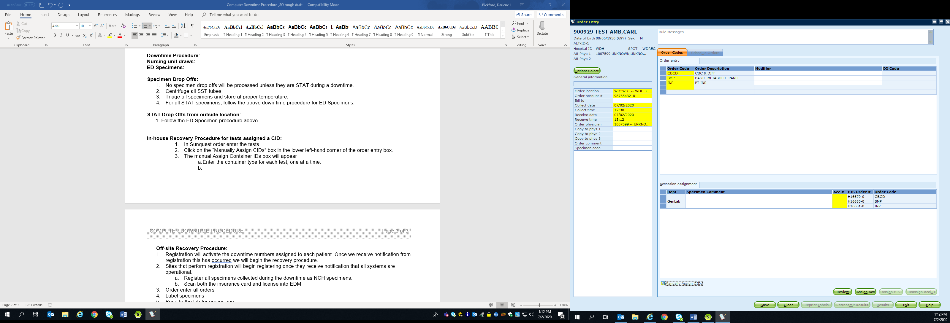

- The manual Assign Container IDs box will appear
    - The yellow fields are mandatory. Start with the Container.
    - Select the appropriate container type for the first available test listed (Ex. LV)
    - Select the appropriate specimen type for the first available test listed (ex. BLD)
    - When there is more than one test for the selected container and specimen type you can hold the Shift key down and click on all of the appropriate available test codes.
    - When the Component Tests field is yellow it will default to <ALL> leave it on All.
    - Internal CID field. Enter the assigned CID from the label affixed on the requisition.
    - Make sure the Radial button beside Reprint CID Label is on YES.
    - Click on Add
    - Continue until all Available order codes are added. Make sure the Internal CID is entered accurately for each specimen.
    - Click OK
    - Sunquest labels will print. Bring the labels to the designated departments.
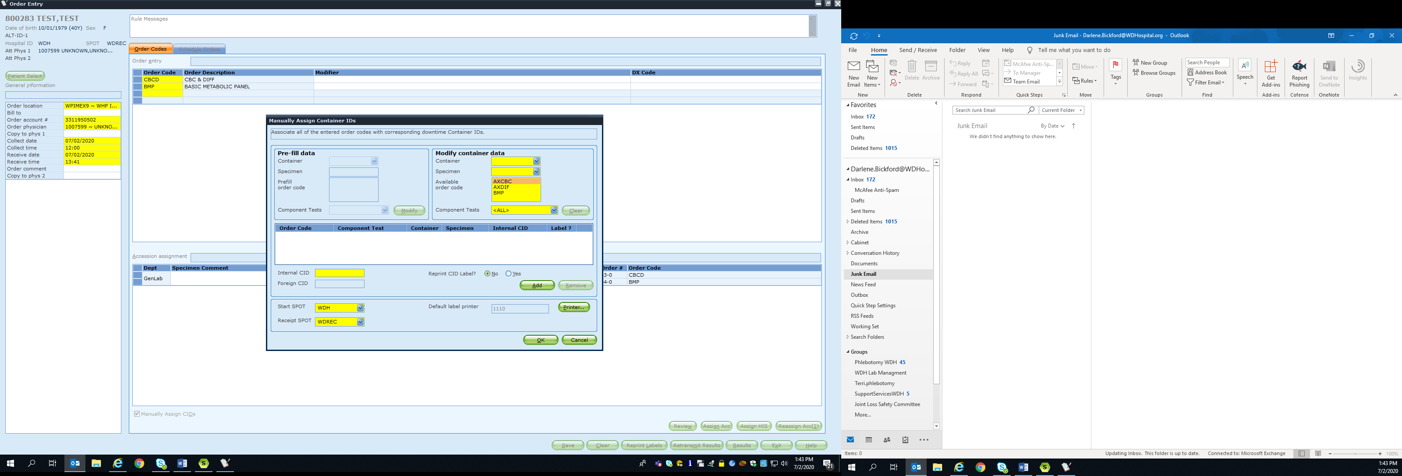
- Scan the requisitions into the corresponding encounter for documentation in Media Manager within Epic.
Inhouse Pre-printed labels from the pending:
- Using the downtime log, go back into the original accession and correct the time of collect and date if necessary.
- Receive the samples

Routine Lab Specimens without Manual CIDs assigned:
Obtain all specimens that were held during the down time from the ambient, refrigerated and frozen buckets and their corresponding requisitions.
- Order enter each per policy
- Label specimens per policy
- Deliver specimens to the corresponding departments for processing.
- Scan the requisitions into the corresponding encounter for documentation in Media Manager within Epic.
Off-site Recovery Procedure (Paper Orders):
- Create an HOV for each patient serviced during the downtime.
- Order enter directly into Sunquest according to the requisition
- Label specimens per policy
- Prepare for transport to the main lab for testing.
- Scan the requisitions into the corresponding encounter for documentation in Media Manager within Epic.

**At the conclusion of downtime recovery gather all downtime supplies, to include labels and the bins and place back into the downtime bin for storage. Do not leave the bins out.**

