**To Update Printer in Lattice (Desktop ONLY)**

* **Log into Lattice**
* **The next screen is to Select Printer**
  + **Make sure *Zebra CPCL Network Printer* is selected**

## 

## **Stop with solid fill**** If you print a label and the FONT or PATIENT INFORMATION (*should not be upside down*) does not look like the example – You can update printer (see instructions below) and reprint labels – BEFORE EXITING COLLECTION SCREEN**

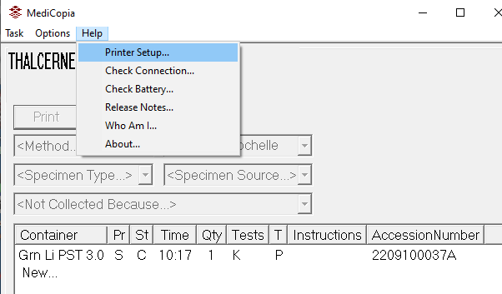

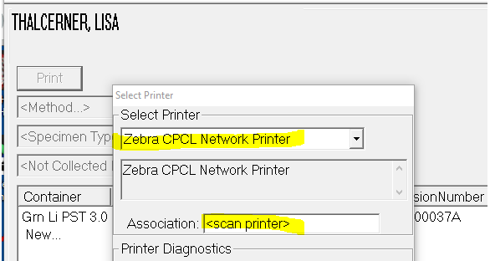

## **Lattice may need to rescan the Patient’s armband. Choose “YES” for the message below.**

## 