LabCorp Order Entry Instructions

- Locate the patient by entering ‘Patient Name’ or ‘MRN’ in the designated field.  – Press the ‘Enter’ key or click ‘Create Order’ | 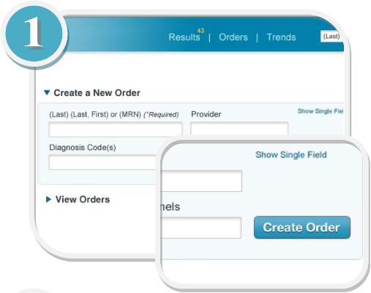
- The ‘Confirm Patient Information’ screen appears:  – Confirm patient information  – Enter patient demographics retrieved from Care Connect  – Bill Method: Client  – Click ‘Continue’ | 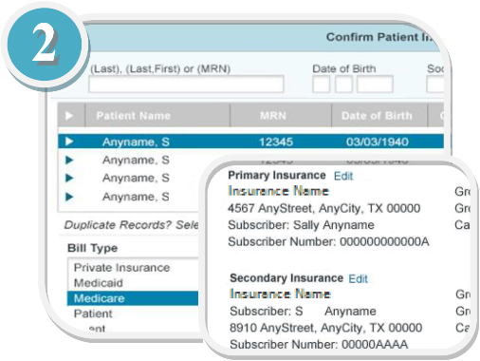
- The ‘Standard Order Entry’ tabs appear; the ‘Order Details’ builds on the right (See Figure 6 below).  – Utilize the tabs to proceed; select the ‘Diagnosis’ tab  (Example: J12.9 Viral Pneumonia)  – Utilize ‘Search’ or type ahead to locate a diagnosis code; select the appropriate diagnosis code check box (View Care Connect)  – If needed, utilize ‘Picklist’ to select the appropriate diagnosis code  – If needed, utilize ‘Add to Picklist’ to add a diagnosis code to a designated picklist | 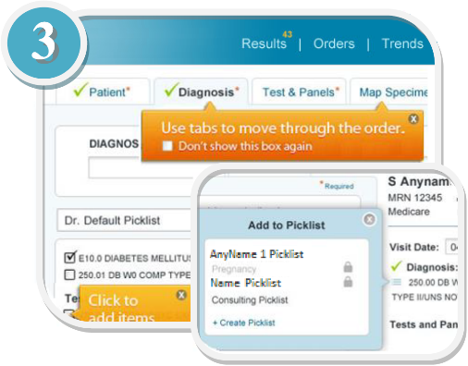
- Select the ‘Test & Panels’ tab and select the appropriate codes:  – Utilize ‘Search’ or type ahead to locate a code (search by ‘Test Code’, ‘CPT Code’ or ‘Keyword’)  – 2019 Novel Coronavirus (COVID-19), NAA (Test Number 139900)  – If needed, utilize ‘Picklist’ or ‘Shortcut’ to select code  – If needed, utilize ‘Add to Picklist’ to add a test code to a designated picklist  – DO NOT SELECT PSC | 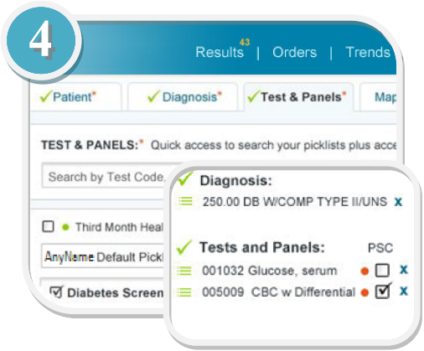
- Select the ‘Map Specimen’ tab and complete the required information and select the ‘Provider’ tab:  – Utilize ‘Search’ to locate a provider  – If needed, utilize the ‘Picklist’ to select a provider  – Utilize the ‘CC Fax Results’ to fax results to our lab or a physician  – Texas Health Rockwall Lab Fax Number: (469) 698-1151 | 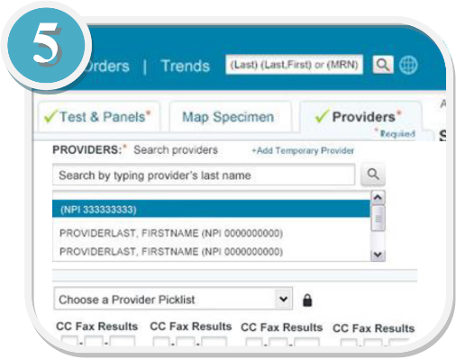
- ‘Order Detail’ options:  - Use to change the location (not applicable)  - Use to edit patient information  - Use to place a ‘STAT’ order (BE SURE TO CHECK)  - Use to change visit date  - Use to add to picklist  - Use to delete an item  - Use to send to ‘PSC’ (DO NOT USE)  - Use to place a ‘Standing’ Order  - Use to review the order  - Use to save an order  - Use to cancel an order  – Select ‘Review Order’ to continue; the ‘Clinical and Specimen Information’ screen appears – If needed, edit the ‘Fasting’, ‘Call Results (BE SURE TO CHECK)’, and ‘Clinical Comments’ (if statement)  – If the testing being ordered require additional information, the appropriate fields will be made available  – Click ‘Save’ to continue | 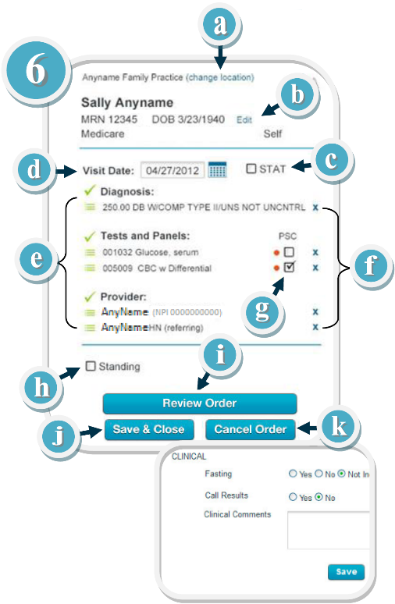
- The ‘Collection Requirements’ screen appears by default; click the ‘Processing Instructions’ tab to view detailed process information:  – Enter collection time at the top of screen.  – To complete the order at a future date, click ‘Save & Close’ or click ‘Cancel Order’ to cancel the order  – Go to Processing Instructions and enter “1” as specimens  – To submit the order and generate the requisition for printing, click ‘Submit Order’ | 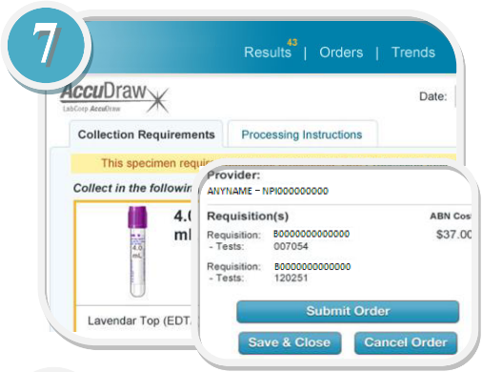
- The requisition appears in PDF format; utilize the toolbar option to manage the requisition:  – Utilize the ‘View Orders’ tabs (‘Completed’, ‘Saved’, ‘Standing’, ‘To Manifest’, and ‘Alternate Lab’) to view orders  – Place LabCorp requisitions forms in printer for label purposes, otherwise write requisition number on each specimen.  – Go to ‘To Manifest’ to print requisition.  – Print manifest to create transfer list. | 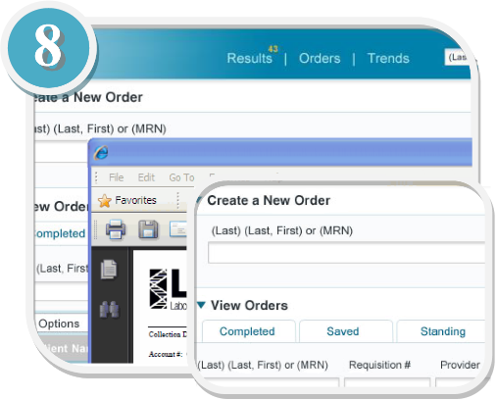

How to add a provider

Settings Admin Add new user User Role: Ordering Provider Username for physicians – Initials3150 (Example NF3150)

