- VERIFY the patient’s identity.  OBTAIN 3 patient chart labels and match with the patient’s hospital armband.  ASK patient to verbally verify his/her identity at time of specimen collection.  DRAW a 7mL EDTA pink top pre-transfusion specimen per protocol.  NOTATE on 2 patient chart labels the Collector ID, Witness initials, Date, and Time of collection. | 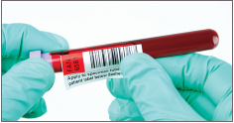 | 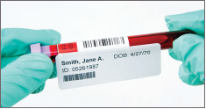 | 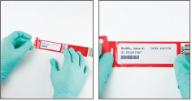
 | - PEEL the specimen tube sticker from the blood bank band and place it on the specimen tube lengthwise. “Apply to specimen tube & patient label below dashed line.” | - APPLY a patient chart sticker with collection information onto the blood specimen tube sticker beneath the dashed lines. | - PLACE a patient chart sticker with collection information on the designated area of the band with comment “Place patient information here”.  PEEL the liner from the shield and cover the patient label with the shield.  SEAL the edges down on a flat surface using your fingers.
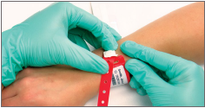 | 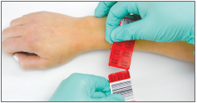 | 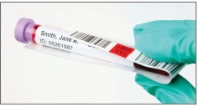 | 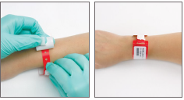
- WRAP the band tail around the patient’s extremity to size.  SNAP the button closure to secure. | - REMOVE the tail of stickers from the band at the perforation leaving 1 BBID barcode and 3 BBID sticker labels to place on order forms. | - PLACE patient chart label on tail of stickers from band and place in specimen bag or attach tail of stickers to the specimen bag. | - PEEL the adhesive tab on the underside of the extra stickers and secure the extra stickers to the band for future use when placing BBID sticker on order forms.

