

Laboratory Staff

MISC Test Ordering

**Description:**

To ensure testing is ordered appropriately to avoid delays in resulting and patient treatment.

**Content/Steps:**

1. **MISC Test that are not listed in CareConnect may be ordered as Other Laboratory Order.**

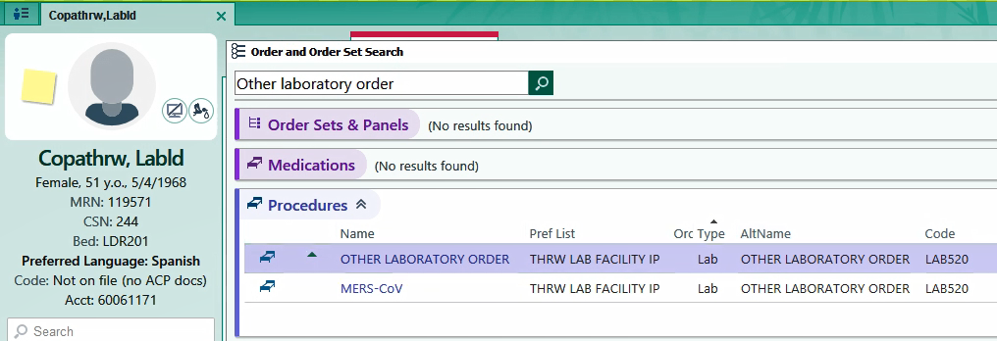

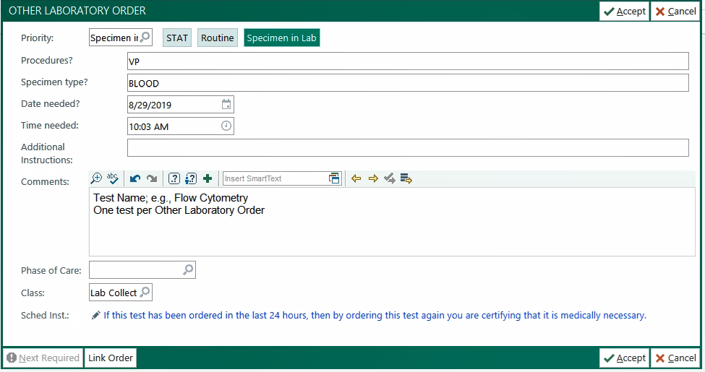

**Step 1:** List Procedure; e.g., Venipuncture

**Step 2:** In the Comments Section list the individual test name.

***Place an “Other Laboratory Order” for each test (For billing purposes)

**Step 3:** List Diagnosis, Test Code, or CPT if available

If you have any questions, you can contact the THRW Special Processing/Send Out Coordinator for assistance.

**Lauren Hajek, MBA, BS, MLS**

Special Processing

(469) 698-1178

[lauren.hajek@phrtexas.com](mailto:lauren.hajek@phrtexas.com)