Conversation Launcher to Un-discharge a Patient

\*Please ensure that the patient is currently ADMITTED in Care Connect before proceeding

1. Add Conversation Launcher to you App Bar. See below.



1. Once you have added the icon, click on it and the Person Mgmt: Conversation Launcher box will open. Select the Un-discharge an Encounter application.

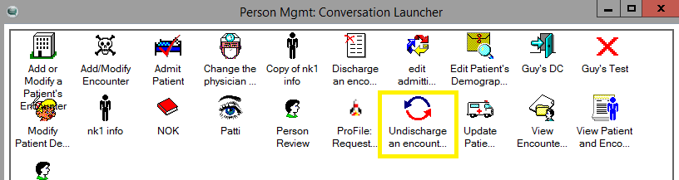

1. In the Encounter Search box, enter the Financial Number (beginning with a 6) appropriate patient information and select the patient you want to un-discharge.

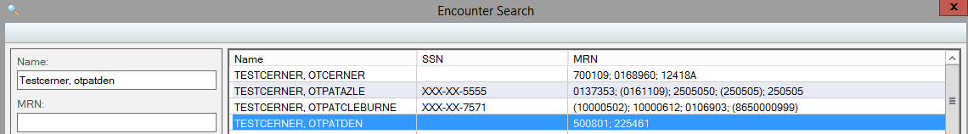

1. In the Undischarge an encounter box, select the Discharge Disposition and click “OK”. You are done!

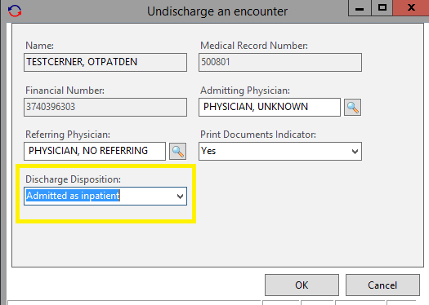

1. Check ORV to verify that the patient is no longer discharged in Cerner.