

Laboratory Staff

Multi-step collect for non-blood specimens

**Description:**

For non-blood specimens to appear in Cerner, specimens must be collected in CareConnect. Nurses typically perform this task; however, to avoid delays please find instructions on how to perform the multi-step collect for non-blood specimens. There are two methods to perform this task, from patient list and patient station.

**Content/Steps:**

1. **Multi-step collect from Patient List**

Step 1: Highlight patient from Patient List and select the arrow at the bottom of the screen.

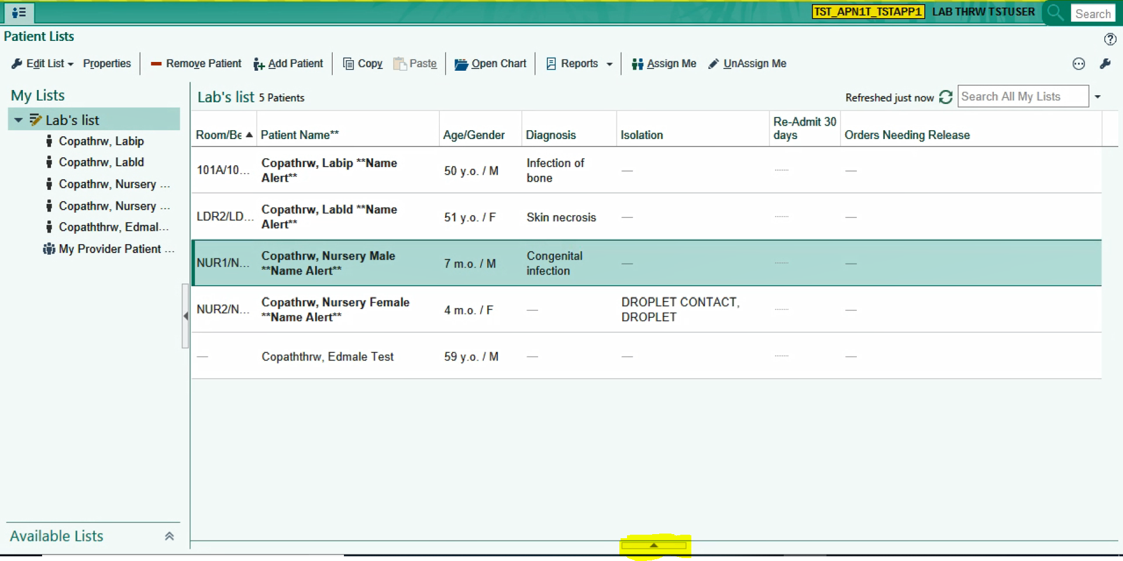

Step 2: Select Multi-Step Collect

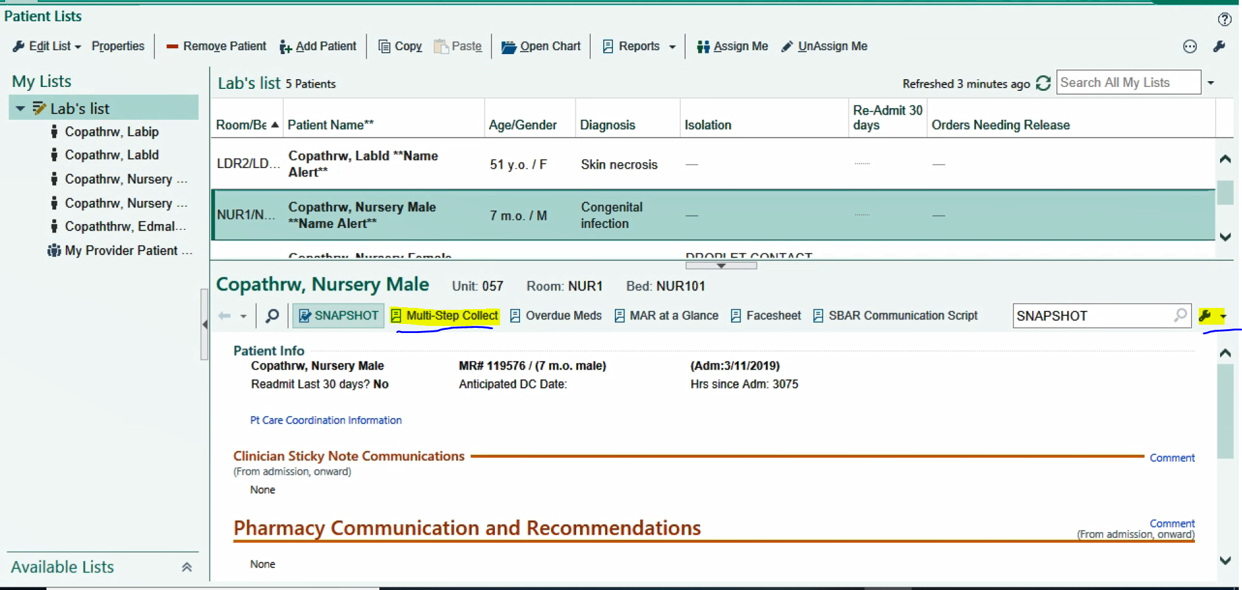

Step 2A: To add multi-step collect to your toolbar click on the wrench highlighted on the toolbar above to the right of the screen.



Step 2B: Type in Multi-Step Collect in the available field and click Accept.

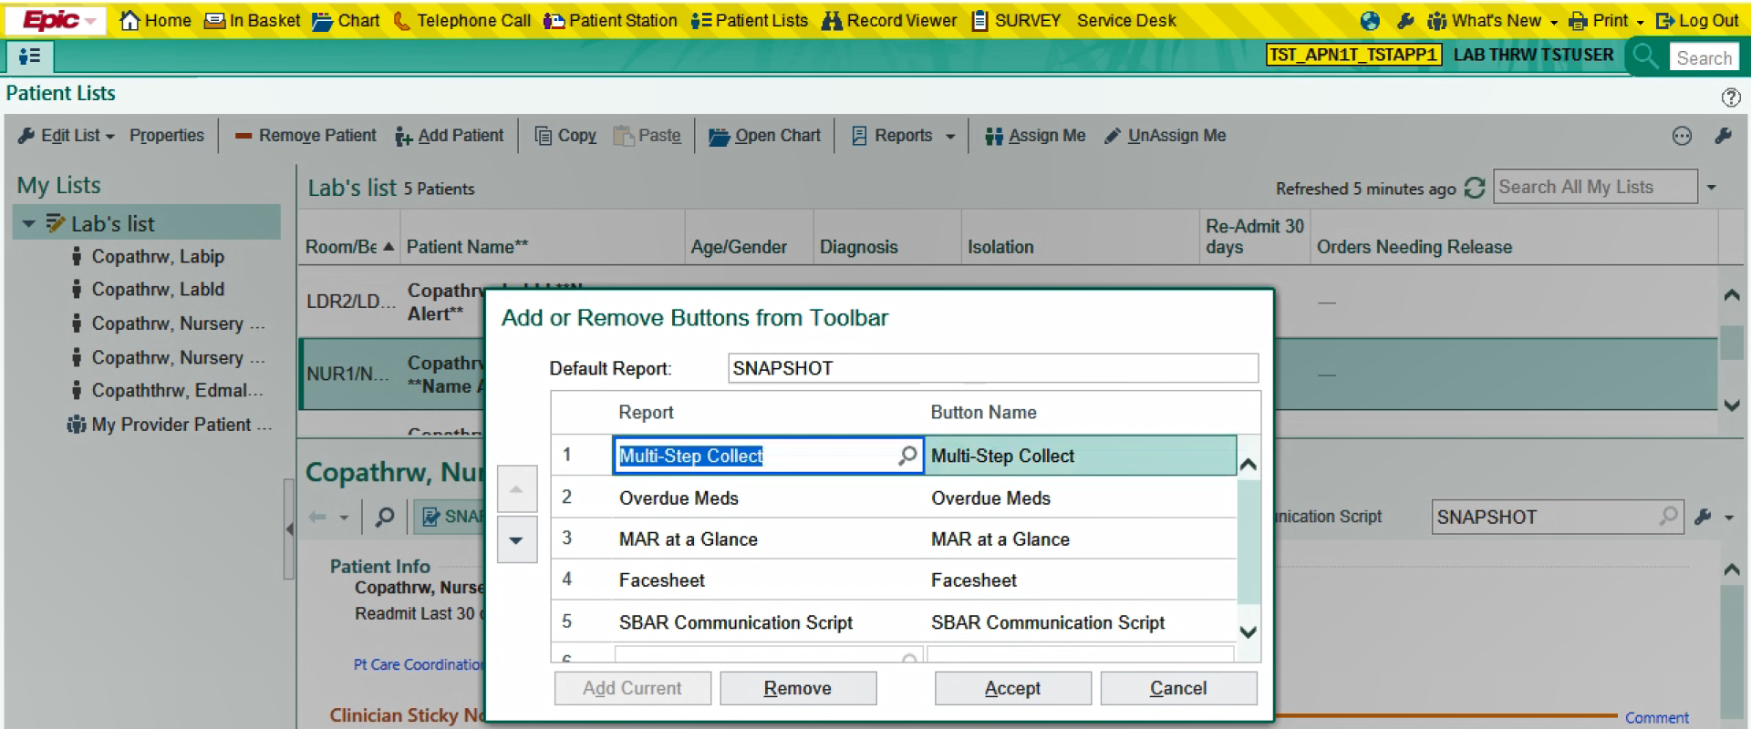

Step 3: Select the Multi-Step Collect tab on the toolbar and click on Collect Specimen for Urinalysis Screen with Conditional Microscopic.

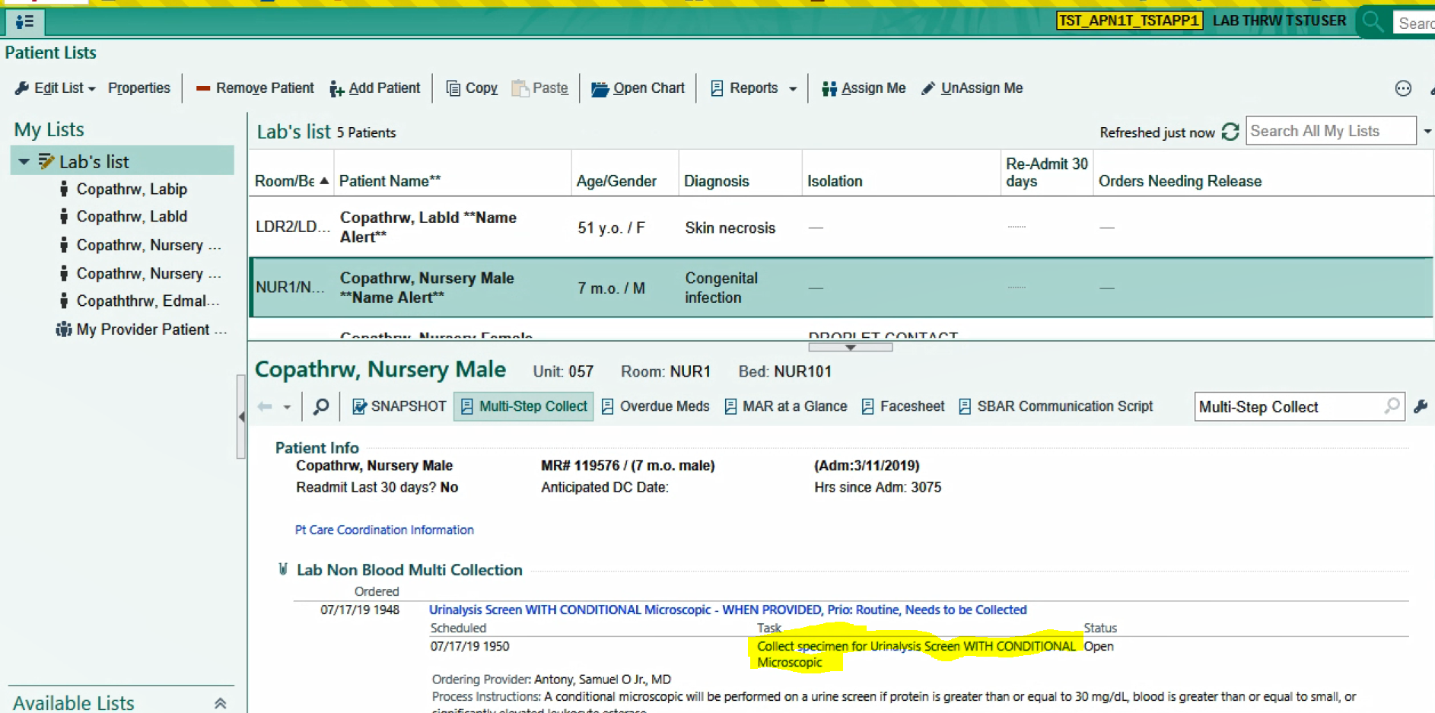

Step 4: Enter Collection Date and Time

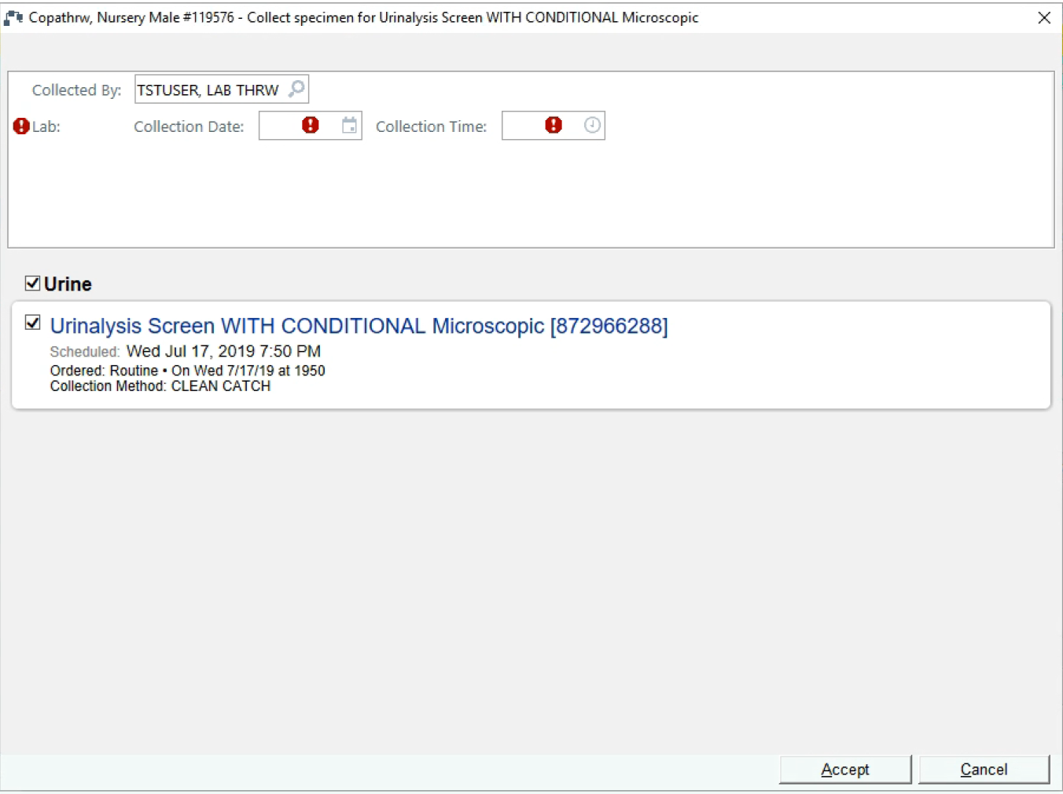

1. **Multi-step collect from Patient Station**

Step 1: Select Patient Station and enter relevant information

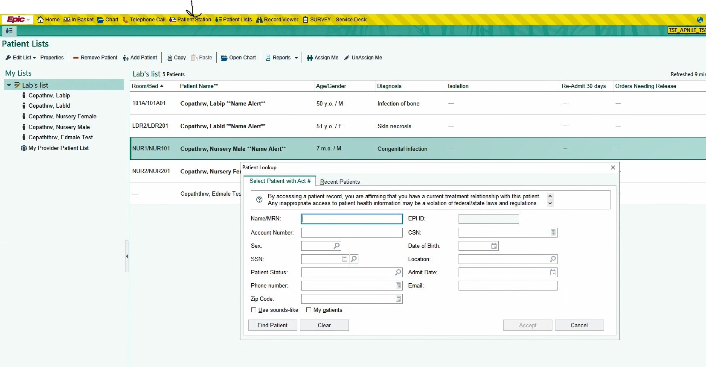

Step 2: Click on the Admission Encounter:

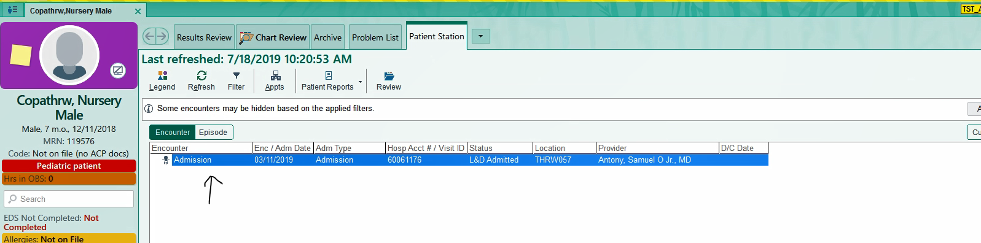

Step 3: From the summary tab, you will find Multi-step Collect on your toolbar.

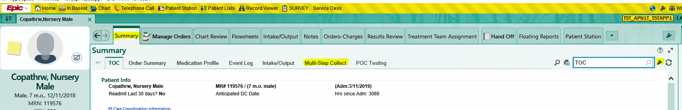

Step 3A: To add Multi-step Collect to your toolbar select the wrench on the right side of the toolbar.



Step 3B: Type in multi-step collection and accept.

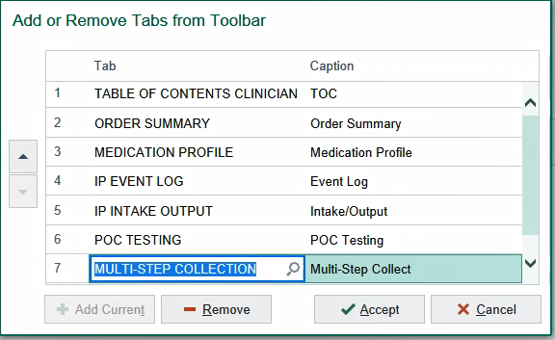

Step 4: Click Multi-Step Collect tab on the toolbar then click Collect specimen for “lab non blood specimen”.

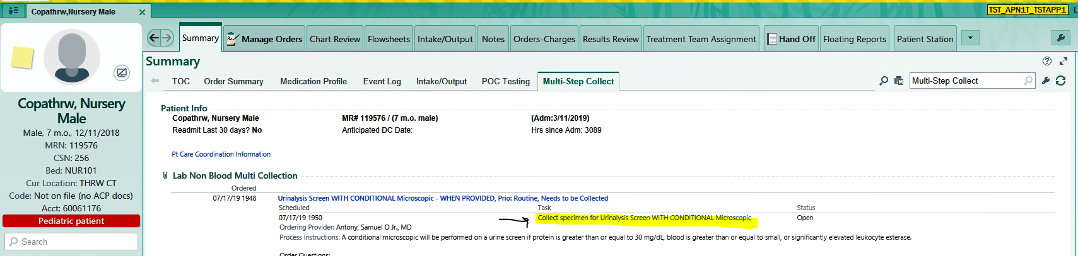

Step 5: Enter Collection Date and Time



If you have any questions, you can contact the THRW LIS Coordinator for assistance.

**Wayne Wilson, MT**

LIS Coordinator

(469) 698-1755

[deshon.wilson@phrtexas.com](mailto:Deshon.wilson@phrtexas.com)