|  |  |  |  |  |
| --- | --- | --- | --- | --- |
|  | **Test Name** | **Age Restrictions** | **Ordering** | **Specimen** |
|
| **Urine** | SANE Urinalysis | None | UASANE/LAB 5099 | Urine |
| Pregnancy Test, Qualitative, Random, Urine | None | UHCGSC/LAB437 | Urine |
| **Chlamydia** | SANE-Chlamydia and GC by PCR | ≥ 14 Years | ZCGNAS/LAB5117 | * Orange Aptima Tube1-Vaginal, Oral, Rectal * White Aptima Tube2-Endocerivcal, Urethral * Urine |
| Chlamydia trachomatis and Neisseria gonorrhoeae by Transcription-Mediated Amplification (TMA) | < 14 Years | CTNGA/LAB 3290 | Urine |
| Chlamydia trachomatis Culture* | None | CATRCA/LAB244 | BD Universal Viral Transport3 |
| **Gonorrhea** | SANE-Chlamydia and GC by PCR | ≥ 14 Years | ZCGNAS/LAB5117 | * Orange Aptima Tube1-Vaginal, Oral, Rectal * White Aptima Tube2-Endocerivcal, Urethral * Urine |
| Chlamydia trachomatis and Neisseria gonorrhoeae by Transcription-Mediated Amplification (TMA) | < 14 Years | CTNGA/LAB 3290 | Urine |
| SANE- Gonococcus Culture* | None | ZCXGCS/LAB5093 | BBL Culture Swab4 |
| **Other Bacterial** | Culture and Smear, Bacterial | None | ZCXBAC/LAB5092 | BBL Culture Swab4 |
| **Genital** | SANE-Wet Prep Sexual Assault | None | ZWETPS/LAB2287 | BBL Culture Swab4 |

* Molecular testing used for screening as needed. Culture may be used if symptomatic or otherwise indicated.

1 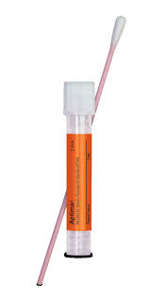 2 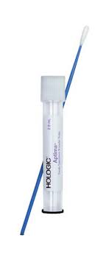 3 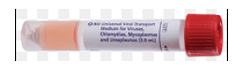 4 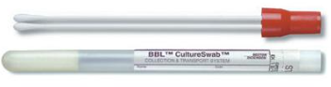

All body sites for PCR and culture require a separate collection tube.