LMC In-house Testing

Specimen type/Source | Patient Age | Test name/Performing Lab | Collection Container/Swab | Methodology
Urine  Male or Female | >14 years | CHLGC  (Chlamydia trachomatis & Neisseria gonorrhoeae)  LAB2096  LMC -Microbiology | Sterile Urine Cup/ Abbott Multi-Collect Kit (Swab)  OR 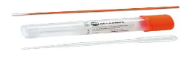 | DNA Amplification
Swab  Vaginal  Endocervical  Rectal  Throat | >14 years | CHLGC  (Chlamydia trachomatis & Neisseria gonorrhoeae)  LAB2096  LMC -Microbiology | Abbott Multi-Collect Kit (Swab) | DNA Amplification
Urine (Male & Female) | >14 years | STI Panel 3 Components  Chlamydia trachomatis, Neisseria gonorrhoeae, & Trichomonas vaginalis  LAB5028  LMC-Microbiology | Sterile Urine Cup/ Abbott Multi-Collect Kit (Swab)  OR | DNA Amplification
Urine (Male & Female) | >14 years | STD1  Chlamydia trachomatis, Neisseria gonorrhoeae, Trichomonas vaginalis, & Mycoplasma genitalium  LAB4623  LMC-Microbiology | Sterile Urine Cup/ Abbott Multi-Collect Kit (Swab)  OR | DNA Amplification
Swab  Vaginal  Endocervical | >14 years | STI Panel 3 Components  Chlamydia trachomatis, Neisseria gonorrhoeae, & Trichomonas vaginalis  LAB5028  LMC-Microbiology | Abbott Multi-Collect Kit (Swab) | DNA Amplification
Swab  Vaginal  Endocervical | >14 years | STD1  Chlamydia trachomatis, Neisseria gonorrhoeae, Trichomonas vaginalis, & Mycoplasma genitalium  LAB4623  LMC-Microbiology | Abbott Multi-Collect Kit (Swab) | DNA Amplification
Vaginal | All ages | VPAT  Vaginal Pathogens by PCR, Candida species, Candida glabrata,  Candida krusei, Trichomonas vaginalis, Bacterial vaginosis  LAB1903  LMC Immunology | BD Molecular Swab Collection Kit OR    BD MAX UVE Collection kit  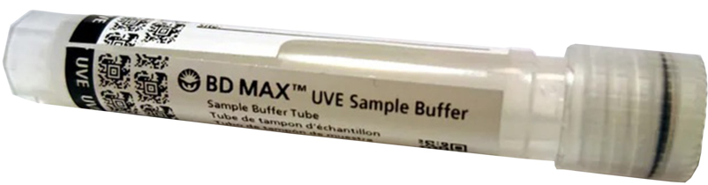 | PCR
Send out Testing

Specimen type/Source | Patient Age | Test name/Performing Lab | Collection container/Swab | Methodology
Throat  Rectal  Endocervical | <14 years | CTNGTMA  (Chlamydia trachomatis & Neisseria gonorrhoeae)  LAB2096  LABCORP | Aptima Unisex Swab Specimen Collection Kit   | Nucleic Acid amplification (NAA)
Male Urethral | All ages
Vaginal | <14 years | CTNGTMA  (Chlamydia trachomatis & Neisseria gonorrhoeae)  LAB2096  LABCORP | Aptima Multitest Swab Specimen Collection Kit  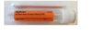 | Nucleic Acid amplification (NAA)
Vaginal Swab | All ages | NUSWBPL  (Vaginitis, Candidiasis, Chlamydia trachomatis, Neisseria gonorrhoeae, Trichomonas vaginalis)  LAB4564  LABCORP | Aptima Multitest Swab Specimen Collection Kit OR  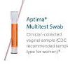  Aptima Unisex Swab Specimen Collection Kit  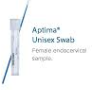 | Nucleic Acid Amplification (NAA)
Vaginal Swab | All ages | NUSWBCA  (Vaginitis, Candida albicans, Candida glabrata, Candida tropicalis, Candida parapsilosis, Candida lusitaniae, Candida krusei, Trichomonas vaginalis)  LAB4565  LABCORP | Aptima Multitest Swab Specimen Collection Kit OR  Aptima Unisex Swab Specimen Collection Kit | Nucleic Acid Amplification (NAA)

