EpicCare Link Account Set-up Guide

Getting Started 2

Browser, System, and Connection Requirements 2

EpicCare Link Account Request 2

Account Set-Up 5

Logging in for the first time 5

Two-factor Authentication 6

Challenge Questions / Password Recovery / Reset Authentication 8

Reset 2FA for a new device 9

I have my current device: 9

I do not have my current device but I have my Reset code: 10

I do not have my current device or reset code 11

Help and Contact Information 11

Getting Started

EpicCare Link is a tool that provides real-time web access to patient information so you can access patients' clinical data and communicate with Norton Healthcare to provide quality patient care. You can also use EpicCare Link to quickly refer patients to our organization.

This guide will help you with the process of requesting access to Norton’s EpicCare Link web portal and setting up two-factor authentication.

Browser, System, and Connection Requirements

Windows

* Google Chrome 80 or later
* Microsoft Edge version 88 or later
* Microsoft Internet Explorer 11
* Mozilla Firefox version 78 or later

Tablets

* iPad Safari
* Android Chrome

Other Requirements

* Minimum screen resolution of 1024x768 pixels.
* High-speed Internet connection
* Browser must have java enabled to display graphs and scanned images
* Epic Authenticator two-factor authentication app

EpicCare Link Account Request

Please follow the steps below for requesting access for a new practice. It is very important that you have identified a **Site Administrator** for all new requests. A **Site Administrator** should be a user who accesses EpicCare Link regularly and can verify users. This person is responsible for requesting new user accounts, deactivating the accounts of users that are longer active at your site. **Every site must have at least one site administrator.**

1. Open your browser and access the following URL: http://NortonEpicCareLink.com
2. Select Request New Account

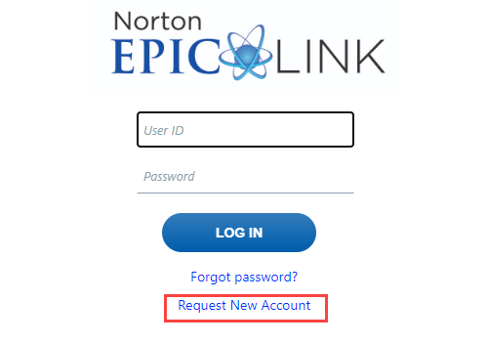

1. Select Request a new site, then choose one of the type of site options.

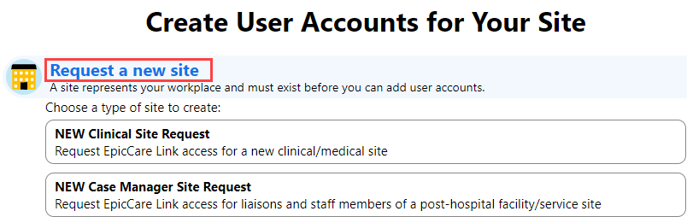

1. Fill out the  required information about your site. Click  next.

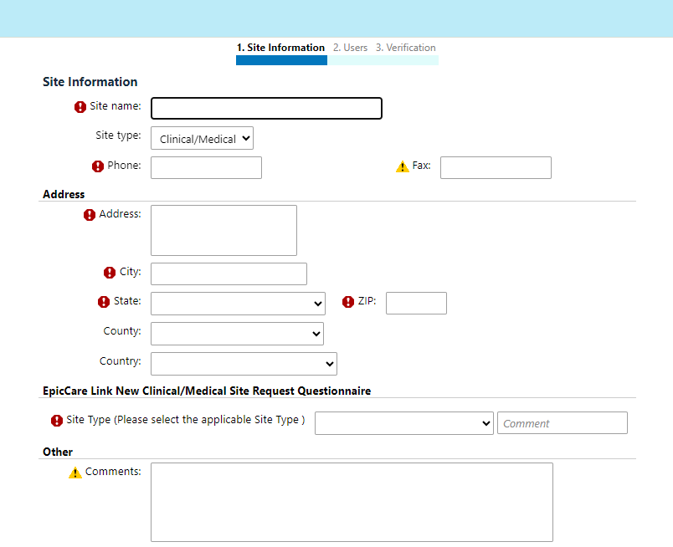

1. Select an appropriate user role (this screen will have different options for case management).

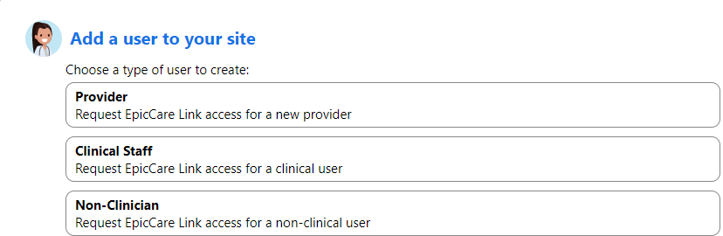

1. The user account request screen will populate. Request access for staff who will need to look up medical records and submit referrals. All users must have their own log in credentials.

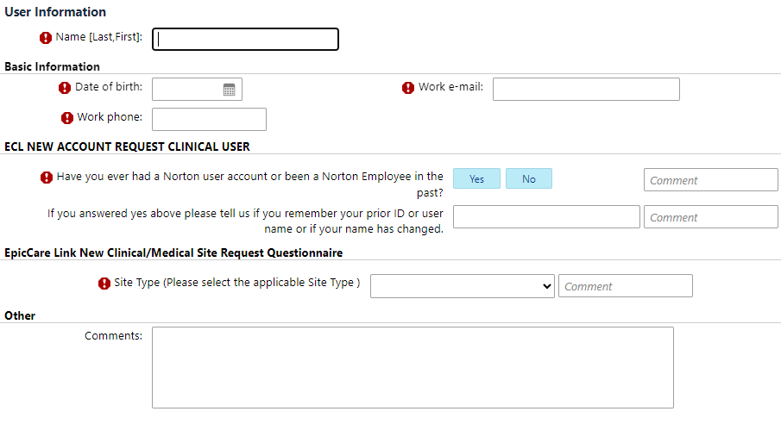

|  |  |
| --- | --- |
| 🛈 | Shared email addresses are not allowed. If no work email is available, a personal email (that is not Hotmail) is acceptable. |

1. Designate a Link Site Administrator, this person will be responsible for adding, removing and verifying users.

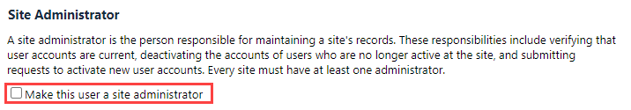

1. The Verification activity will populate. Read and agree to the terms and conditions. Complete all  required fields.
2. Click  **Submit Request**.

|  |  |
| --- | --- |
| 🛈 | Please note that after you submit your request a confirmation page will be displayed. Please keep the reference number for your records. This reference will be used to track the process of the account creation requested.  You can print this confirmation page by clicking the C:\Users\vendwjtn\AppData\Local\Temp\SNAGHTML1f360724.PNG icon in the top right of the screen. |

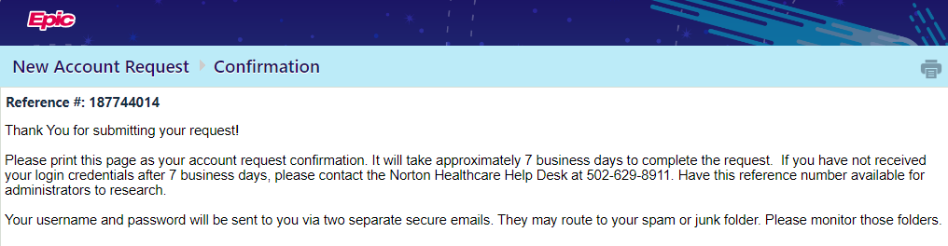

1. Each users will be emailed their own log in credentials. Please allow up to 7 business days for processing.
   1. **User name and temporary passwords will be sent in two separate emails after the account is created**. If you do not receive the emails, please take the following steps:
      1. Check your junk folder
      2. Check with your service team to determine if firewall settings are blocking the encrypted emails.
      3. Please contact the Norton Healthcare Service Desk at 502-629-8911, option 4, if assistance is needed

Account Set-Up

Logging in for the first time

|  |  |
| --- | --- |
| ! | **In order to maintain active EpicCare Link access, you must log in within each 90 day period.** A lapse in login activity will require an access request resubmission. |

1. Open your web browser and access the following URL: http://NortonEpicCareLink.com
2. Enter your Norton ID and Temporary Passcode (your passcode is case sensitive) provided in the email you received. If you do not have a temporary passcode or experience any issues during the setup process, please call the Service Desk at 502-629-8911, option 4. When calling, please provide your practice name, user name and reference number readily available.

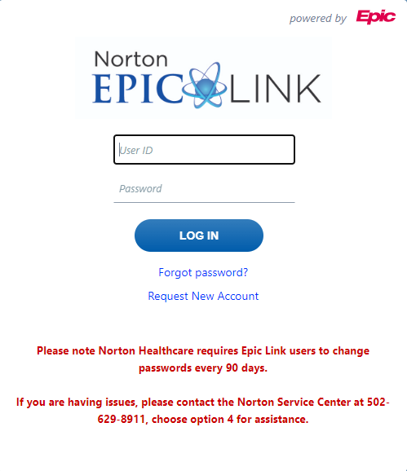

Two-factor Authentication

1. You will then be prompted to set up your two-factor authentication.

|  |  |
| --- | --- |
| ! | **Skipping the setup of two-factor authentication will result in being unable to access EpicCare Link.** |

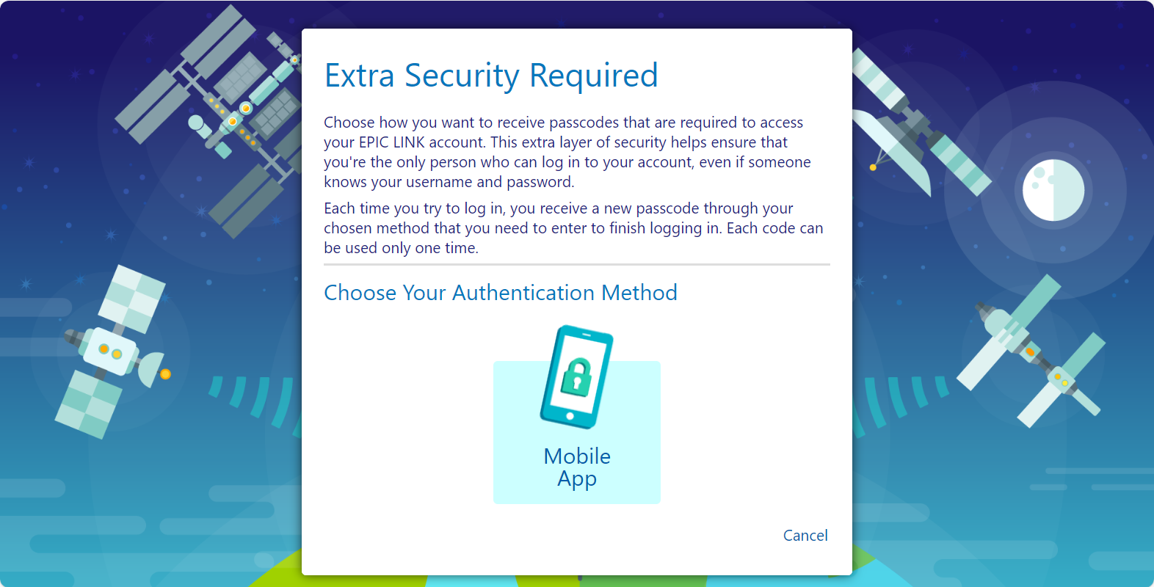

1. You will need to download the Epic Authenticator app which is available on Android or iPhone.

**Apple App Store Android Google Play**

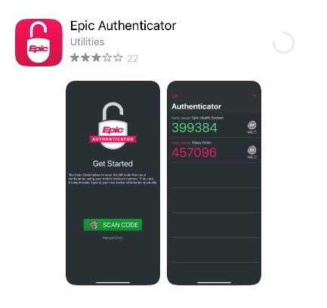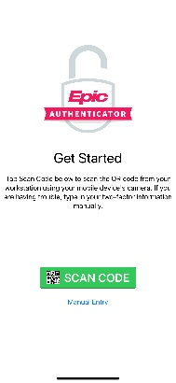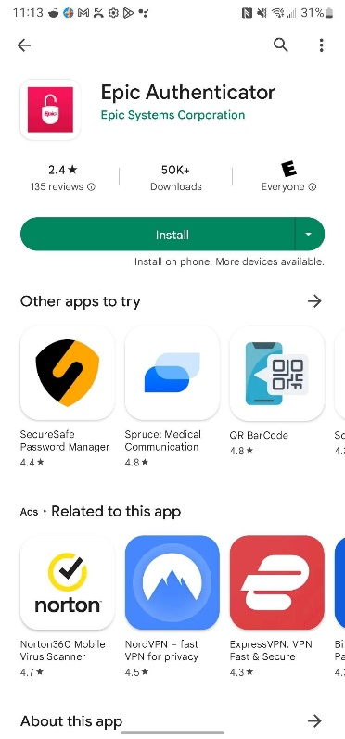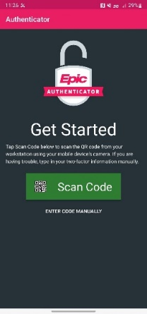

1. Click on ‘Mobile App’
2. Using the camera on your phone, scan the QR code from your screen with your camera, this will take you to the Epic Authenticator app. If prompted, select yes to add the token titled Norton Healthcare.

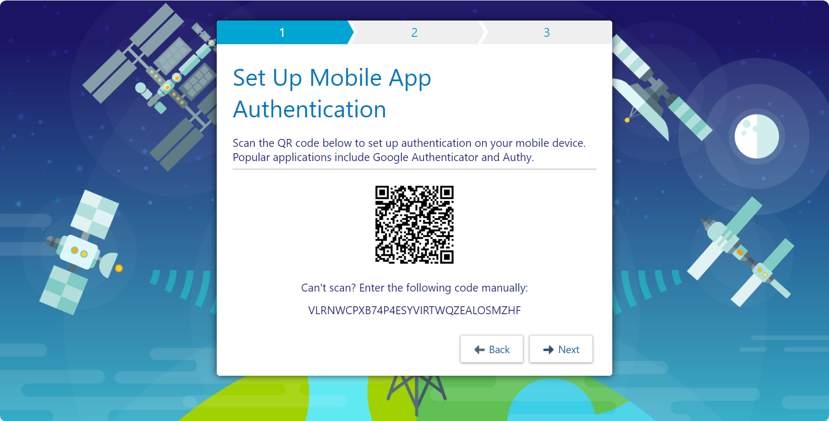

1. Within the Epic Authentication app select Norton Healthcare and enter the passcode that was provided within the app on your mobile device.

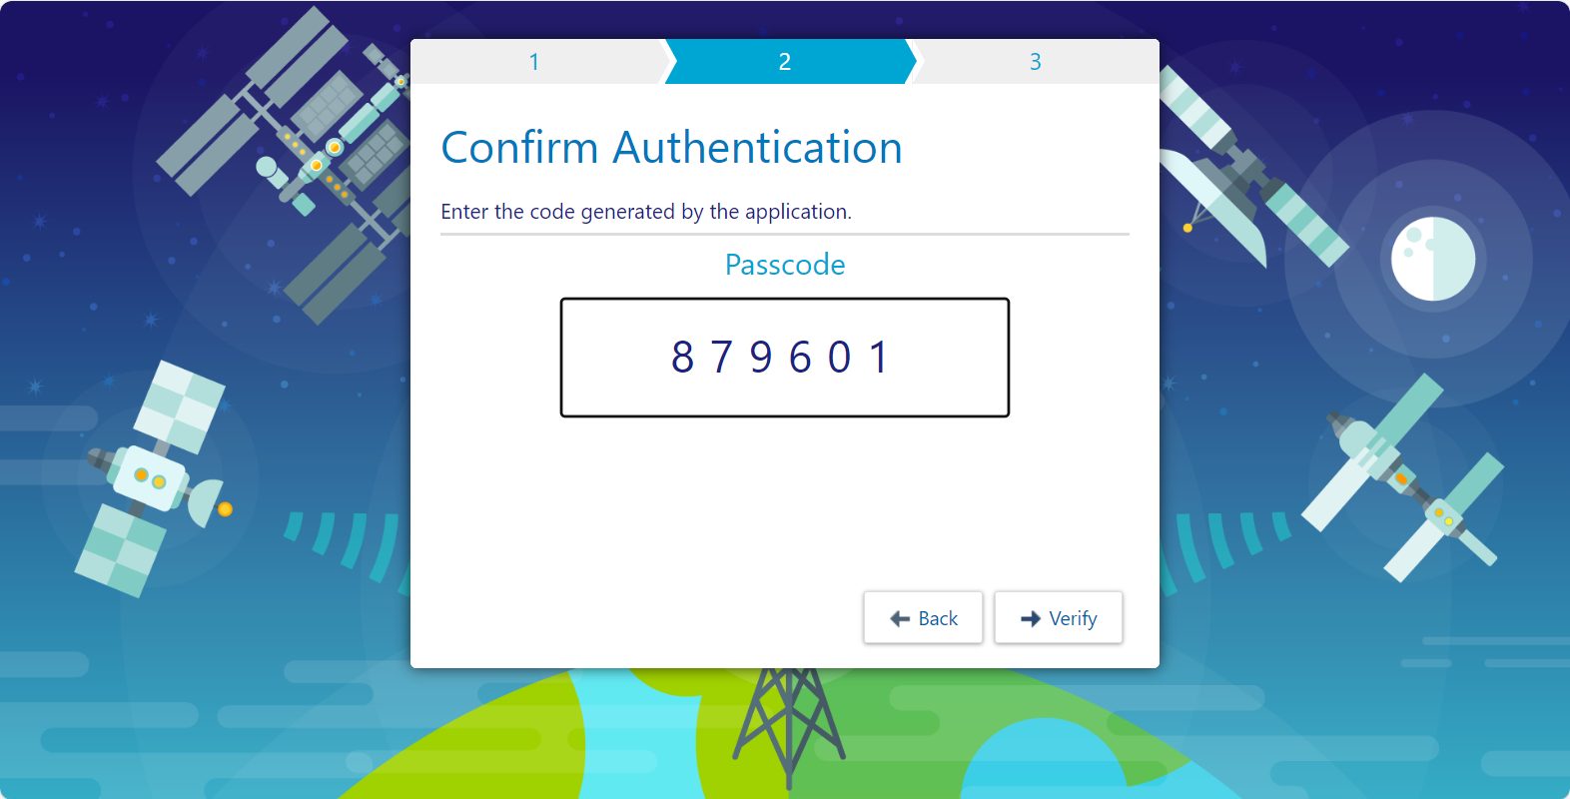

1. When you first set up two-factor authentication, you will receive a reset code that you can use to reset your two-factor authentication settings from the login screen. Please write this down, this code only appears once.

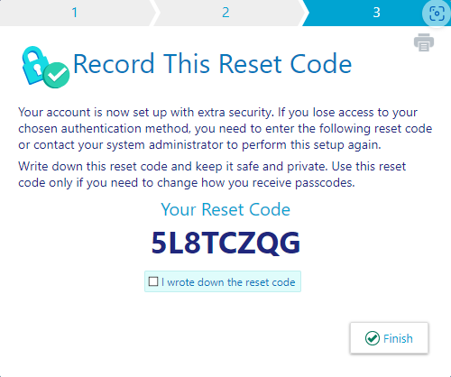

1. Once you have set up your smartphone, tablet or non-smart phone, click **Next**.
2. You will be prompted to change your password. Norton Healthcare now requires a 12 character complex password following the below requirements:
   1. The 12 character password must contain three of these four criteria:
      * Uppercase letter
      * Lowercase letter
      * Number
      * Special character from this list: ~ ! @ # $ % ^ & _ - + = ’ / \ ( ) { } [ ] : ; > , . ?
   2. Once you have entered your new password twice, click **Save** password.
3. Once you are logged in, a Terms and Conditions page will appear. Read and acknowledge the agreement to continue to EpicCare Link.

|  |  |
| --- | --- |
| 🛈 | Once logged into EpicCare Link you will be prompted to create Challenge Questions. These challenge questions will allow you to reset your password from login screen of EpicCare Link. |

|  |  |
| --- | --- |
| ! | Please note that upon each sign into the Norton Healthcare EpicCare Link site you will need to open the authenticator application on your mobile device to authenticate. |

Challenge Questions / Password Recovery / Reset Authentication

|  |  |
| --- | --- |
| ! | **Passwords expire automatically every 90 days without notification. If you previously activated your account and are unable to log in, your password may be expired**. |

**If you have forgotten your previous password**, open your browser and access the following URL: <http://NortonEpicCareLink.com>. Click Forgot password and follow the prompts to change your password.

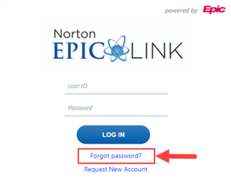

**If you know your previous password** you can change it by logging into EpicCare Link, selecting the  **Menu** button, selecting  **Settings**. From this activity you can change your password, reset your authenticator and update your challenge questions.

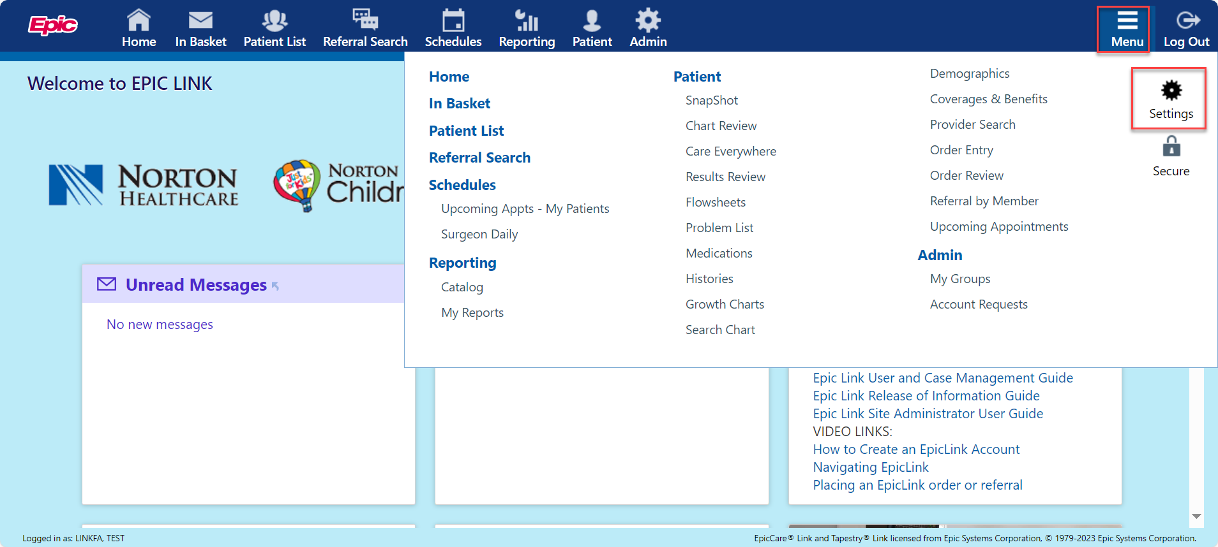

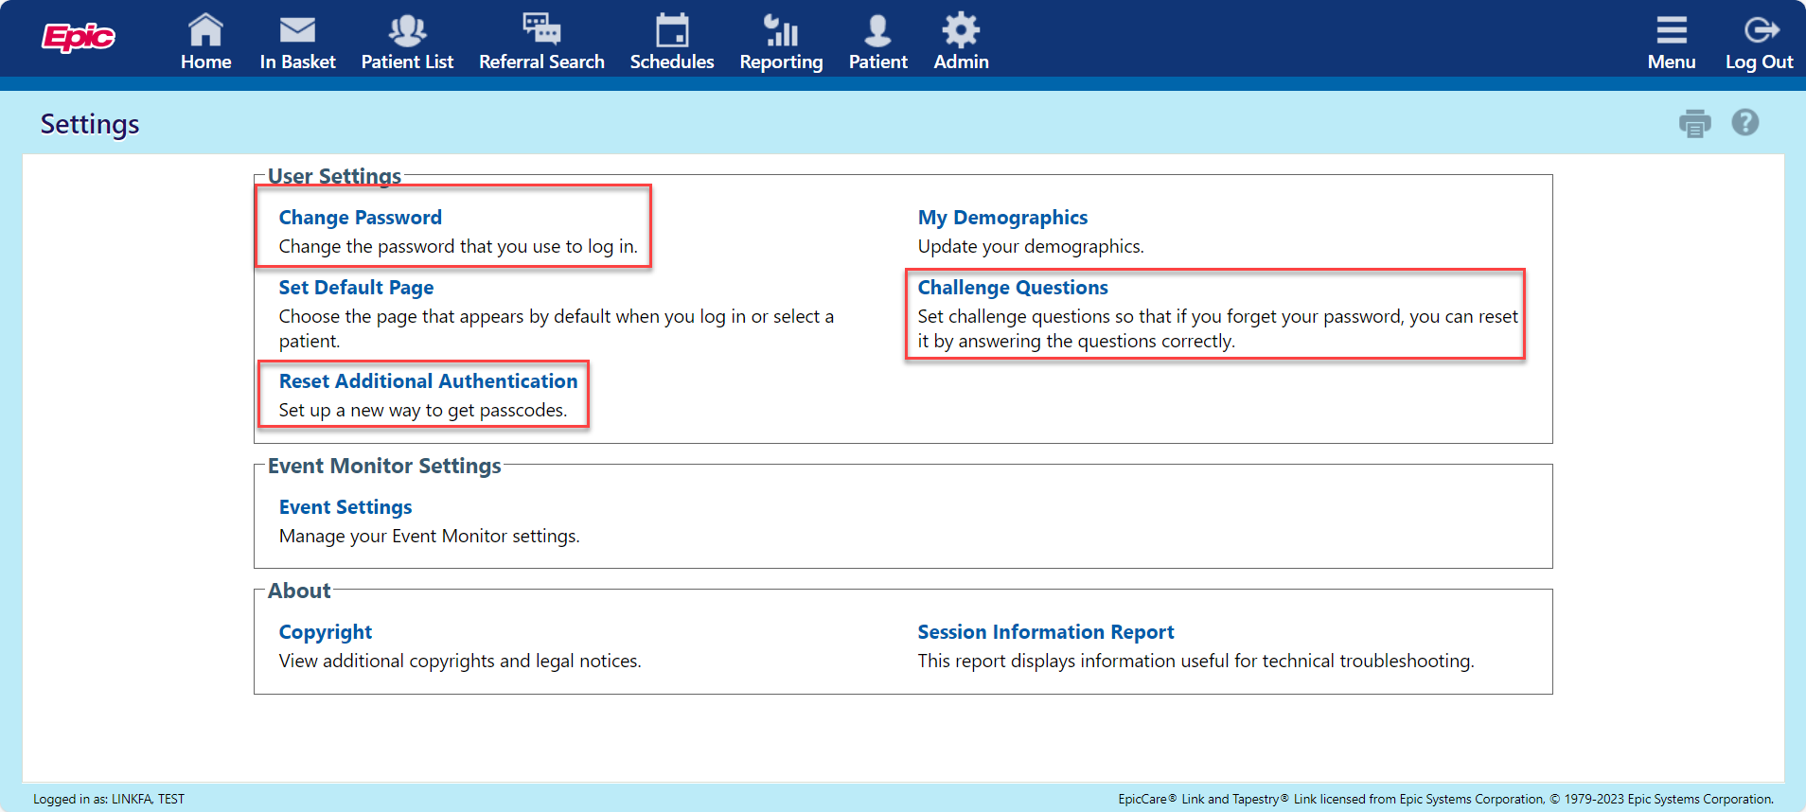

Reset 2FA for a new device

I have my current device:

If you still have your current device reset 2FA by selecting the  **Menu** button, selecting  **Settings**. From this activity you can reset your authenticator. Follow the prompts and set up your new device. It will require the code from your Epic Authenticator App.

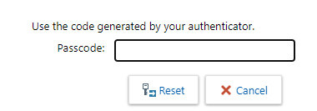

I do not have my current device but I have my Reset code:

If you have your reset code, navigator to the login page, enter your username and password. On the passcode screen select the link **Reset additional authentication** and on the next screen enter your Reset code provided to you during your set-up. Follow the prompts to finish setting up your new device.

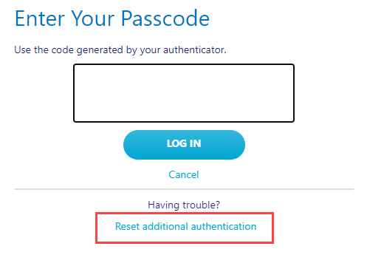

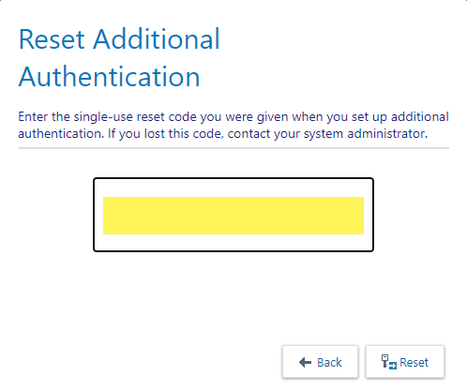

I do not have my current device or reset code

If you do not have your current device or the reset code provided to you during set-up, please call our service desk at 502-629-8911, option 4 to reset your 2FA.

Help and Contact Information

If you have attempted to activate your account and update your password, but you are still unable to login, please call the **Norton Healthcare Service Desk** at **502-629-8911, option 4**.