June 1, 2022
Re: Soluble CD163 (sCD163) Test Method/Reference Range Change

Dear Cincinnati Children’s CBDI Clinical Laboratory Clients:

A new sCD163 method is in effect as of 6/3/2022. sCD163 is now measured by an automated microfluidics immunoassay method.Values of sCD163 measured with the current method generally run 25% lower than when measured with the previous ELISA method.
The current reference range is ≤1333 ng/mL for <3 years of age and ≤911 ng/mL for ≥3 years of age.

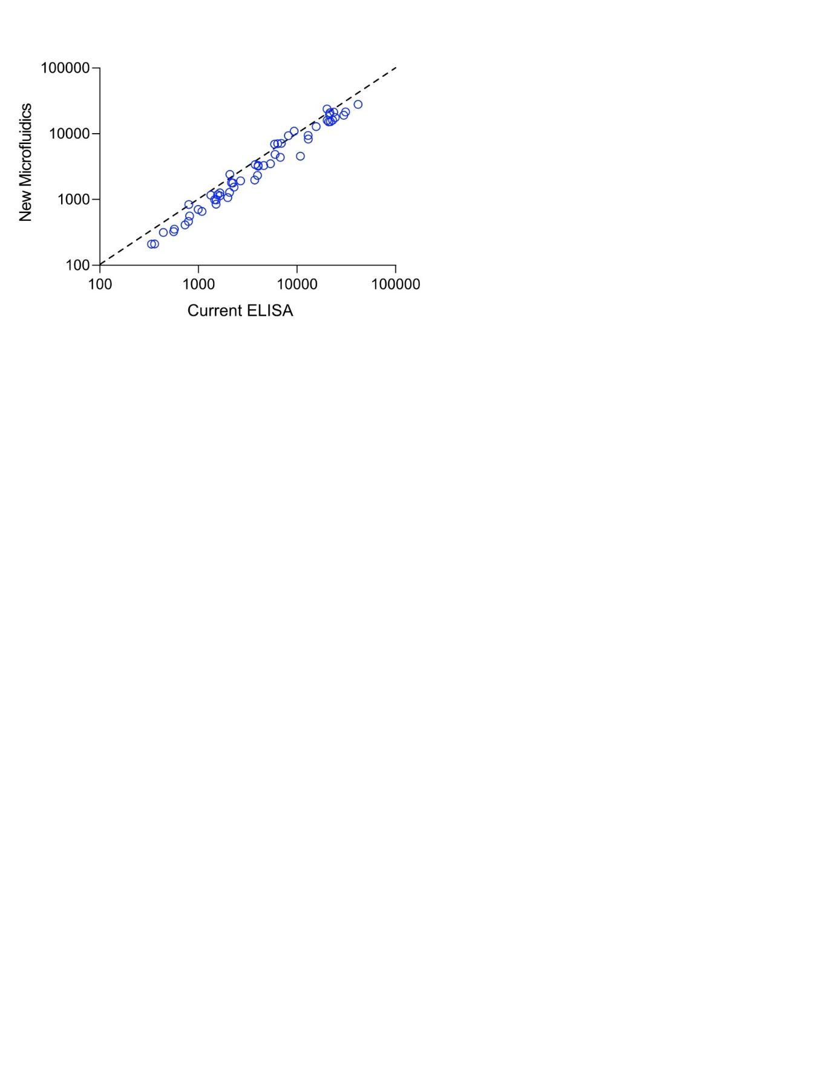
Graph showing the correlation of sCD163 sample values obtained using the ELISA method versus the automated microfluidics immunoassay method. While both methods are highly comparable, the microfluidics method returns numerically slightly lower readouts. Values plotted as ng/mL, both axes transformed to Log₁₀. Dotted line represents x=y.

Collection Instructions:
3mL whole blood should be collected using EDTA as an anticoagulant (lavender top tube). The minimum blood volume is 1mL whole blood in a lavender top tube.

Handling Conditions: Keep samples as whole blood for delivery to our lab within 24 hours of collection. If delivery cannot occur within 24 hours, separate plasma from cells within 24 hours of collection. Freeze immediately at -20°C or lower.
Samples should be sent appropriately to maintain proper storage/transport conditions until received in our lab. Whole blood must remain at room temperature after collection until received in our lab. Separated plasma samples that have been frozen must be sent with enough dry ice to maintain a frozen state until received in our lab.
All vials should be labeled with patient name, MRN, DOB, date of sample collection, and anticoagulant.
Please also refer to our requisition for sample collection and shipping instructions.

Please feel free to contact us with any questions you may have.
Thank you.
The CBDI Diagnostic Immunology Laboratory at Cincinnati Children's
Phone 513.636.4685 | Fax 513.636.3861 | Email: CBDILabs@cchmc.org
3333 Burnet Avenue | R2328 | Cincinnati, Ohio 45229-3039
www.cincinnatichildrens.org/DIL

