Specimen Centrifuging
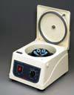
- When using a serum separator tube, red top tube, or PST tube, collect the specimen using standard venipuncture technique.
- Gently invert the tube five (5) times to mix the clot activator with the blood. Avoid vigorous agitation of collected specimens.
- Allow the tube to clot for 20-30 minutes in a vertical position.
- Do not centrifuge immediately after drawing the blood.
- Do not allow the blood to clot with the tube in a horizontal position.
- Do not allow the tube to stand more than two hours before centrifuging.
- Centrifuge the tube for 10-15 minutes
- Insert the tubes into the centrifuge ensuring the centrifuge is balanced (ex: if you place a 10ml red top you must have a 10ml red top directly across from it with equal amount of liquid etc…)
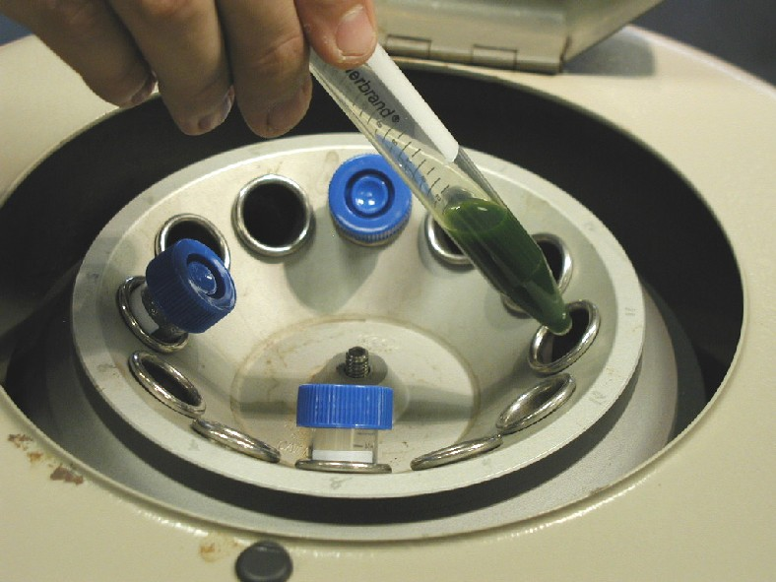
- After centrifugation, the gel in SST tube and PST should be intact and the cells and serum completely separated by the gel barrier. Do not re-centrifuge the tube if the barrier is incomplete. The Red top tubes will have the same separation minus the gel barrier; keep the red top tubes in an upright position until the serum is aliquotted from the tube.

SST Tube Red Top Tube
(after centrifuging) (after centrifuging)
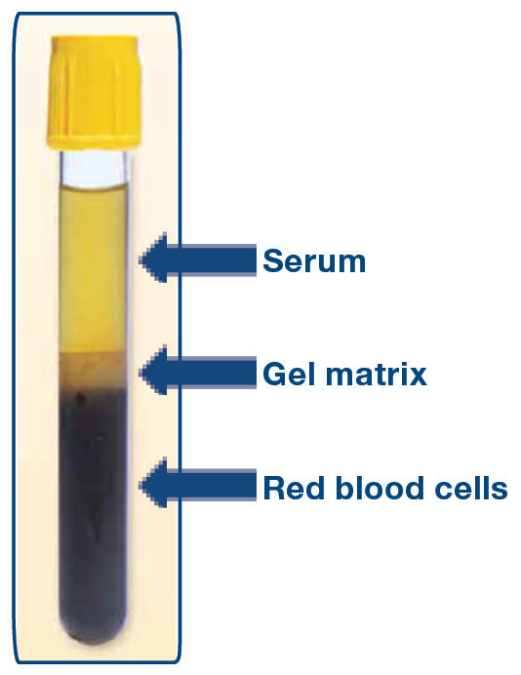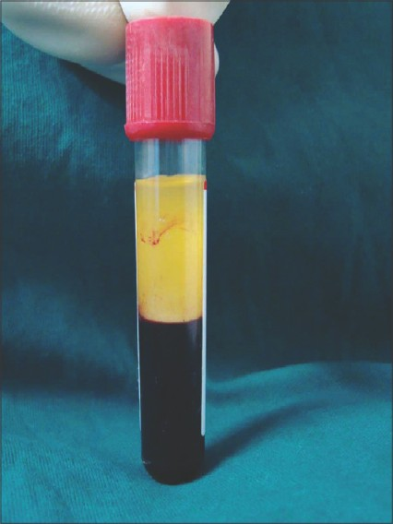
Serum

Red blood cells

