HIV TESTING ALOGORITHIM
Guidance for Providers on Ordering HIV tests in EPIC

Questions, Contact BWMC Microbiology at 410-787-4542
Or a laboratory Pathologist

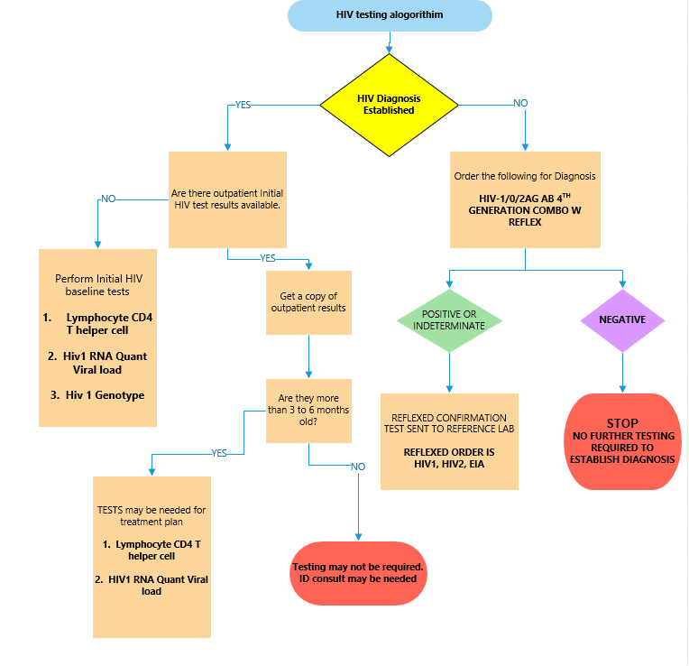

Date completed: January 2020 / TH

