

Metal-Free Trace Element Urine Specimen Collection, Processing & Storage

**Urine Collection:**

* Use a sterile plastic container for collection
* The container must not have metal caps or glued inserts
* The container should not be colored due to metals found in dyes
* Ensure container is labeled with at least two unique patient identifiers
* Minimize contamination of the sample by avoiding contact with the inside of the container or lid
* **Random Collection:** First-morning urine is recommended for a spot or random collection
* **24-Hour Collection:** Do not urinate directly into the 24-hour collection container. Collect urine in a clean plastic container and carefully pour into the 24-hour collection container. If possible, keep 24-hour collection container refrigerated during collection

**Processing:**

* Immediately transfer 8.0mL of urine from a well-mixed, sterile plastic cup or 24-hour collection container to the ARUP metal-free trace element aliquot container with the blue cap. Minimum volume is 2.0mL.

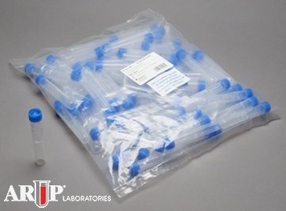

**Storage & Transport:**

* Preferred Storage: Refrigerated (2 week)
* Acceptable Storage: Ambient (1 week); Frozen (1 year)