List of Interfering Substances in Gonorrhea and Chlamydia Testing

This applies to the following Gonorrhea and Chlamydia test codes:

**GCLSNA**, **CLMSNA**, **GCSNAA**, **GCLUNA**, **CLMUNA** and **GCUNNA**.

Products containing carbomer(s), including vaginal lubricants, creams and gels may interfere with Chlamydia and Gonorrhea testing results, and should not be used during or prior to collecting urogenital specimens.

Carbomer containing products in urogenital sites

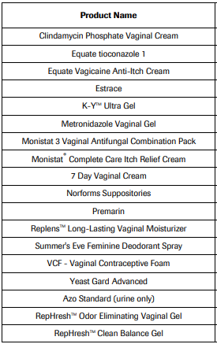

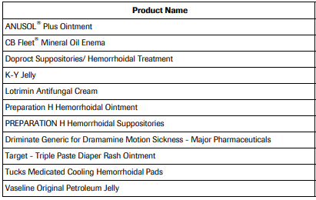 Carbomer containing products in anorectal sites

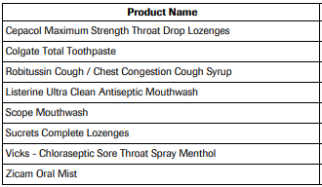 Carbomer containing products in oropharyngeal sites